WHITEHAVEN TOWN COUNCIL

Clerk and Responsible Financial Officer: Chairman:
Marlene Jewell Telephone: 01946 67366 Councillor Chris Hayes

To: Members of Whitehaven Town Council

You are duly SUMMONED to attend a MEETING of WHITEHAVEN TOWN COUNCIL which will be held in THE BEACON PORTAL at THE BEACON, WHITEHAVEN on THURSDAY 31st
March 2022 at 6:00pm

Signed.... .. tl . . ········· Dated.-4.-. . V:i
Marlene Jewell, Clerk and Responsible Financial Officer

AGENDA

- • Apologies for Absence

- Declarations of Interest
... 4?.?.2-

To receive declarations of interest by elected Members in respect of Agenda items.

If a Member requires any advice on any item involving a possible declaration of interest which could affect his/her ability to speak and/or vote he/she is advised to contact the Clerk at least 24 hours in advance of the meeting.

- Public Participation

- Minutes of the Council Meeting held on 24th February 2022

- Planning Applications

- Finance Report

- Queen's Platinum Jubilee Commemorative Gifts for School Pupils

- Badge Bed at Corkickle

- Christmas Lights Infrastructure

- Consultation on two potential Sites for Gypsy and Traveller Accommodation

- Replacement of compost due to infestation of Vine Weevil 12.In Cumbria Advertising

13.Edible Insects Science Show 14.Councillor Ward Matters
- Date and Time and Venue of Next Meeting IN PRIVATE
That prior to the following items of business the Chairman will move the following resolution:

That in view of the special or confidential nature of the business about to be transacted it is advisable in the public interest that the public and or press be instructed to withdraw.

- Lease of Former Editors Office 17.Grant Application - WADAOS
- Grant Application - EC

WHITEHAVEN TOWN COUNCIL

Minutes of the Council Meeting held on 24th February 2022

Present: Councinor C Hayes (Chairman); Councillor E Dinsdale; Councillor R Gill; Councillor C Maudling; Councillor B O'Kane; Councillor J Rayson; Councillor G Roberts; Councillor R Redmond;

M. Jewell, Clerk and Responsible Financial Officer V Gorley. Assistant Clerk
Members of the Public

1951/22 Apologies for Absence

Apologies for absence were received as follows: -

Councillor Carr Councillor G Dinsdale
Work Commitments

ill

It was proposed by Councillor Hayes and seconded by Councillor Gill that the apologies for absence given be accepted and note d. A vote was held and it was unanimously

RESOLVED - That the apologies for absence be accepted and noted.

1952/22 Declarations of Interest

Councillor Maudling entered the Meeting and declared an interest in Item 5 as he was a member of CBC's Planning Panel
Councillor Roberts declared that he was a member of Cumbria County Council

1953/22 Public Participation

A member of the public (MB) attended to speak about the West Cumberland Hospital and the lack of coronary care facilities. She said she had had a heart attack last summer with a 99% blockage of her artery. She made the following points: -
- She was in the West Cumberland Hospital for 3 days before she could get a bed in Carlisle

- When she was given a bed, she had to wait for an ambulance which took a further 36 hours
- She was sent to Carlisle at 2.00am in the morning
- All the time she was in West Cumberland Hospital she was in pain and the staff there did the best they could but that healthcare round here was a postcode lottery because if she had had a heart attack in Carlisle there would have been no problem as she would have been taken to the relevant place not stuck for 3 days in West Cumberland Hospital
- She said this was not a rare thing as everybody knows someone who has had a stroke or heart attack and thought it was totally unacceptable that that was what we're presented with in Whitehaven especially as they are spending £40 million on a new hospital and they can't deliver services like that
- There was a sense of isolation as well as although she wasn't allowed visitors because of the pandemic that was an exception rather than a rule. Even though her family were not allowed to visit her she knew people on the ward at West Cumbria Hospital. So, there was a friendly face at a time when she was there not knowing whether she was going to live or die and in pain from the heart attack and nobody knew what treatment she needed until she went to Carlisle
- She said she thought there should be a lot of voices raised in protest at this because it was totally unacceptable
At this point Councillor Roberts declared an interest as he was Chairman of CMTW Partnership and (MB) had written to him and he had forwarded the issue to Health Scrutiny Committee of CCC.
Councillor Gill said the Council should support (MB) on behalf of the people of the Town and said on behalf of the Council that they had no powers to do anything about this but the Council could make its voice heard to those that matter. He said the Council should send a letter of protest to the Health Service at Carlisle stating the Council's disappointment and its desire for the facilities to be re-instate at West Cumberland Hospital.
Councillor O'Kane said this was bigger that Whitehaven and it should go to Copeland Borough Council as well and it was one of those things that everyone had protested about and at the end of the day it was ignored by the Commission that looked into everything. It was so difficult at the moment to try and change what's there but that we still had to try and that when we write the letter it should go to the Elected Mayor with a request that they endorse the feeling of the Town Council.
In response to a question from Councillor Maudling (MB) said she was now
very well
(MB) thanked the Council for listening to her and for giving her their support.

1954/22 Minutes of the Council Meeting Held on 27th January 2022

It was proposed by Councillor Hayes and seconded by Councillor Roberts that the Minutes of the Meeting held on 27th January 2022 be approved and signed by the Chairman as a correct record. A vote was held and it was unanimously

RESOLVED -That the Minutes of the Meeting held on 27th January 2022 be approved and signed by the Chairman as a correct record.

1955/22 Planning Applications

The Council considered a list of Planning Applications received and shown at Appendix 1. It was proposed by Councillor Gill and seconded by Councillor O'Kane that following full consideration of the planning applications that CBC be informed that the Council had no representations to make on the Planning Applications shown at Appendix 1. A vote was held and 7 Councillors voted for and 1 Councillor abstained.

RESOLVED - That following full consideration of the planning applications that CBC be informed that the Council had no representations to make on the Planning Applications shown at Appendix 1.

1956/22 Finance Report

The Council considered a Finance report.
  - Appendix1 - The Assistant Clerk reported that there was 2 extra invoices to be considered namely:

Cumbria Media Westcom
£32.00 for uploading and maintenance of website
£216.00 Annual Licence for Microsoft Azure

It was proposed by Councillor Hayes and seconded by Councillor Roberts that the Invoices shown at Appendix 1 together with the 2 extra invoices above be approved and paid. A vote was taken and it was unanimously

RESOLVED - That the Invoices shown on Appendix 1 together with the 2 extra invoices above be approved and paid.

- Appendices 2 and 3 - It was proposed by Councillor Hayes and seconded by Councillor Gill that Appendices 2 and 3 be approved and noted. A was held and it was unanimously

RESOLVED - ThatAppendices 2 and 3 be approved and noted.
1957/22 Westcom Upgrades of PCS

Following a visit from the Councils IT Contractor the Council considered a report on upg rades/replacement of its 3 PCs. Following a discussion, it was proposed by Councillor Gill and seconded by Councillor Hayes that the 3 PCs be upgraded by the IT Contractor at a cost of £90.00 per PC plus the £50 collection and return fee. A vote was held and it was unanimously

RESOLVED - That the 3 PCs be upgraded by the IT Contractor at a cost of
£90.00 per pc plus the £50 collection and return fee.

1958/22 Hewlett Packard Enterprise Support Scheme

The Council considered a report on the renewal of the Contract for support services hardware with Support Warehouse who act on behalf of Hewlett Packard Enterp1ise at a cost of£ 109.00 plus VAT for 1 year. It was proposed by Councillor Roberts and seconded by Councillor Gill that the Contract with Support Warehouse on behalf of Hewlett Packard Enterprise be renewed
for 1 year at a cost of £109.00 plus VAT. A vote was held and it was unanimously

RESOLVED - That the Contract with Support Warehouse on behalf of Hewlett Packard Enterprises be renewed for 1 year at a cost of £109.00 plus VAT.

1959/22 Consultation on the Draft of the Copeland Local Plan 2021-2028

The Council discussed the document on the Consultation on the draft of the Copeland Local Plan which had previously been circulated and made the following comments.
- Councillor O'Kane referred to a lack of linkag e with CCC in terms of road provision etc. In the Hensingham area at the top near the school there are several places itemised as present developments. But other potential developments are being put forward but not in the plan. Services underpinning all these several thousa nd houses are not in the plan. There are lots of applications pending and some may be hurried in before the plan takes effect because the plan does n' t appear to allow development in certain areas.
He questioned how binding the local plan was going to be in the future.
When the new plan comes in to what degree will it carry weight. To what degree will applications be entertained from areas outside the zones in the Local Plan.

He said it had taken an age to put together and he wished there was more reference to other bodies especially CCC
- Councillor Gill said all town and parish councils should have been part of the process in formulating the plan
- Councillor Dinsdale queried the long-term date on the Local Plan and said he would be amazed if the new authority wouldn ' t want to revisit it. He said the contentious one for him was the acceleration of the bypass.
It was proposed by Councillor Gill and seconded by Councillor Hayes that it be left to individual Councillors to send their comments to Copeland Borough Council. A vote was held and 7 Councillors voted for the proposal and 1 Councillor abstained.

RESOLVED - That it be left to individual Councillors to send their comments to Copeland Borough Council

1960/22 Recommendations from Events Advisory Group

The Council considered a report on recommendations to full Council made by the Events Advisory Group as follows: -

  - LIGHTING ROUND ST NICHOLAS TOWER - 8 banks of red white and blue for 3 days (Thursday, Friday and Saturday) over the Jubilee weekend. Quotes were sought for the hire of this from the following: - Supplier A referred to internet suppliers but said he could give a quote if req uired . However, a quote has not been received

Supplier B quoted £1,434.12 inc. VAT
Supplier C did not submit a quote as all his equipment had already been booked
RECOMMENDED - That banks of red blue and white lights be erected
round St Nicholas Tower and that the quote from Supplier B of £1,434.12 for the hire of, the erection of and removal of 8 banks of red white and blue lights be accepted.
It was proposed by Councillor Hayes and seconded by Councillor Roberts that the recommendation of the Events Advisory Group above be approved and actioned. A vote was held and it was unanimously

RESOLVED - That the recommendation of the Events Advisory Group in 1 above be approved and actioned.

  - STREET THEATRE - Many professional street theatre companies have no availability but a quote of £1500 was received from a professional street theatre company for 2 days- Friday and Saturday. This will

comprise of a portable kitchen and wheeling it around the Town in various locations and pretending to be celebrity chefs etc
RECOMMENDED - That the professional street theatre company be
Booked at a cost of£ 1500.
It was proposed by Councillor Gill and seconded by Councillor Maudling that the recommendation of the Events advisory Group in 2 above be approved and actioned. A vote was held and it was unanimously

RESOLVED - That the recommendation of the Events Advisory Group in
2 above be approved and actioned

  - FAIR ON HARBOUR - We have arranged for there to be a fair on the Harbourside with the consent of the Harbour Commissioners at no cost to the Council. The fairground provider will supply all necessary documents (risk assessments etc) and certificates for the fairground rides
RECOMMENDED - That this be agreed and confirmed.
It was proposed by Councillor Gill and seconded by Councillor Maudling that the recommendation of the Events Advisory Group in 3 above be approved. A vote was held and it was unanimously

RESOLVED-That the recommendation of the Events Advisory Group in 3 above be approved and actioned

  - A BRASS BAND is available to play on Friday yct June 2022 at a cost of approx. £200.00. Will be playing on the harbour.
RECOMMENDED - That this be agreed and the Band booked
It was proposed by Councillor Hayes and seconded by Councillor Maudling that the recommendation of the Events advisory Group in 4 above be approved and actioned. A vote was held and it was unanimously

RESOLVED - That the recommendation of the Events advisory Group in 4 above be approved and actioned.

  - OTHER POTENTIAL STREET MUSIC ACTS FOR THE WEEKEND - Roving jazz bands etc - £1,000.00
RECOMMENDED - That £1,000 be allocated for the provision of street musical acts
It was proposed by Councillor Hayes and seconded by Councillor
Maudling that the recommendation of the Events Advisory Group in 5 above be approved and actioned. A vote was held and it was unanimously

RESOLVED - That the recommendation of the Events Advisory Group in 5 above be approved and actioned

  - THE READING OF THE PROCLAMATION - The reading of the Proclamation on 2nd June 2022 is being co-ordinated nationally for 1.00pm on 2nd June 2022. It is proposed that this takes place in St Nicholas Gardens led by the Town Crier, (Members will recall that the Council agreed to take responsibility for the Town Crier in September 2021), The Mayor of Whitehaven Town Council and the Mayor of Copeland and that a couple of dozen people be invited (invitations to be sent out early April 2022) to have canapes and cold drink in the Marquee following the Proclamation. If there is no funding available Gerard Richardson has said he will be happy to fund this by using local suppliers.
RECOMMENDATION - That the proposals regarding the
organisation of the reading of the proclamation be approved and that the Council decides whether or not to fund the reception in the marquee following the Proclamation. If the Council decides to fund the reception then there will need to be a resolution that the expenditure complies with section 137 of the Local Government Act 1972. It was proposed by Councillor Gill and seconded by Councillor Hayes that the expenditure for the canapes and drinks, be funded from the Civic Hospitality Budget. A vote was held and 6 Councillors voted for the proposal, and 2 Councillors abstained

RESOLVED - That The expenditure for the canapes and drinks be funded from the Civic Hospitality budget.

It was proposed by Councillor Gill and seconded by Councillor Roberts that it be agreed that the expenditure complies with the provisions of s13 7 of the Local Government Act 1972. A vote was held and 6 Councillors voted for the proposal, and 2 Councillors abstained.

11 RESOLVED - That it be agreed that the expenditure complies with the provisions of s137 of the Local Government Act 1972

  - THE VIKING VILLAGE The Viking Village has said they will be coming over The Platinum Jubilee Weekend. They have not given the actual dates.
RECOMMENDED - That this be noted and that the Clerk inform all
Members of the actual dates when confirmed. This was noted

  - POSSIBLE TALL SHIP in April 2022 )
)Approx. cost of £1,500.00
  - POSSIBLE TALL SHIP in August 2022 )

As Members will know one of the main attractions and success stories of the Maritime Festivals was the visits of Tall Ships and it was recognised in a number of reports including, one written by Wayne Hemmingway in 2004, Broadway Malyan. All the reports recommended increasing the number of Tall Ships visits not only for the economic benefits to the Town but also for the feelgood factor. Sailing ships are part of the historical story of our Town.

RECOMMENDED - That£1500 be allocated for visits from 2 Tall Ships.
It was proposed by Councillor Maudling and seconded by Councillor
Hayes that the recommendation of the Events Advisory Group in 8 and 9 above be approved and actioned. A vote was held and it was unanimously

RESOLVED - That the recommendation of the Events Advisory Group in 8 and 9 above be approved and actioned.

10 . WINDOW DRESSING COMPETITION - The Clerk reported that the Rotary Club and Lara Schwab had said they would be organising a window dressing competition for the Queens's Platinum Jubilee. Lara Schwab was at the Meeting and said she was not actually organising it, it was the Rotary Club.
RECOMMENDED - That this be noted. This was noted
1 1. QUEEN'S PLATINUM JUBILEE SOUVENIRS FOR
SCHOOLCHILDREN - The Clerk reported that some Town Councils were purchasing souvenirs to give to school children as a memento of the
Platinum Jubilee. We have 2,151 primary school pupils and 1,568 secondary school pupils. A search of the internet has revealed that commemorative rulers can be purchased it is suggested for primary school pupils (see Annex 1) at a cost of£ 1.87 per l 000 which would total
£4,022.37 plus VAT and shipping. Commemorative button badges can be purchased at a cost of £24.99 for 50 badges (see Annex 2) which would total £800.00 plus VAT and shipping and this is suggested for secondary school children (not for primary school children as the button badges have a sharp pin).
RECOMMENDED- That the Council purchases commemorative rulers for primary school pupils and button badges for secondary school pupils and that a resolution be made that this expenditure complies with s137 of the Local Government Act 1972 .
It was proposed by Councillor Gill and seconded by Councillor Hayes that it be agreed to go ahead and purchase the rulers and button badges.

An amended proposal was put foiward by Councillor Maudling and seconded by Councillor O'Kane that we leave it in abeyance and that we contact the schools to see what would benefit the children and ask for a reply back by 10th March 2022. A vote was held on the amended proposal and 6 Councillors voted for the amended proposal and 2 Councillors voted against

RESOLVED - That the amended proposal to the original proposal being carried now becomes the substantive proposal.

A vote was then held on the substantive proposal and it was unanimously

RESOLVED - That it be left in abeyance and that the schools be contacted to see what would benefit the children and ask for a reply back by 10 ^{th} March 2022.

- JUBILEE LAMP POST SIGNS - Information was received from the Royal British Legion on Lamp Post Signs for the Jubilee (See Annex 3). These cost £4.99 each but there were discounts depending on the number ordered. The Council currently puts a total of 65 poppies on lamp posts for Remembrance Sunday on Lowther Street, King Street, and the Market Place. It was suggested that in addition to these streets that the
Millennium part of the Harbour be included and it was proposed that 100 lamp post sign s be purchased. These will cost £399.00 excluding shipping costs.
RECOMMENDED -That 100 lamp post signs be purchased and that a resolution be made that this expenditure complies with the provisions of
s137 of the Local Government Act 1972. It was proposed by Councillor Gill and seconded by Councillor Maudling that 100 lamp post signs be purchased and that this expenditure complied with the provisions of s137 of the Local Government Act 1972. A vote was held and it was unanimously

RESOLVED - That 100 lamp post signs be purchased and that this expenditure complied with the provisions of s137 of the Local Government Act 1972.

1961/22 Campaign for Fully Resourced and Consultant Led Coronary and Stroke Care Wards at West Cumberland Hospital

Councillor E Dinsdale thanked the Chairman for including this item on the
Agenda. He said there had been two recent reports related to West Cumberland Hospital about their confidence/capability within West Cumbria and the need to travel to Carlisle and that this had touched a nerve with him and a lot of West Cumbrian residents and a lot of people had left messages on the West

Cumberland Hospital Facebook page about their own personal experiences and
it
had become very apparent that travelling to Carlisle for treatment is costing lives.
As a result (MB) had decided to set up a campaign for consultant led coronary/stroke wards at West Cumberland Hospital The initial campaign will involve setting up a zoom meeting for key stakeholders to get the campaign going and also getting support from other town and parish councils within West Cumbria for the campaign. The people of Whitehaven and West
Cumbria are a first-class community that are being treated like second class citizens. We are asking to be treated within the golden hour which is the most important time to receive treatment when suffering from a heart attack or stroke. It was proposed by Councillor E Dinsdale and seconded by Councillor Maudling that Whitehaven Town Council support this campaign and that the Town Council Zoom platform be used for campaign related meetings. A vote was held and it was unanimously

RESOLVED - That Whitehaven Town Council support this campaign and that the Town Council Zoom platform be used for campaign related meetings.

1962/22 Councillor Ward Matters
  - Councillor Rayson referred to the new charity shop in the old Spar shop at Richmond. She said they were looking for volunteers to do a few hours volunteering and the Charity was keen to work with volunteer Groups here and there
- Councillor Maudling said it had been trouble free in town and that the Police were doing a good job
m. Councillor Gill refelTed to the very bad deteriorating road system at Hensingham and said it was now one big pothole from 1 end of the estate to the other. He said it was an absolute disgrace and that he was going to ask Mike Hawkins to meet him on the estate because something must be done. Councillor Maudling said that the government had allocated 1.2 million of which Copeland would get £200,000.00
1v. Councillor E Dinsdale said he had been contacted by a resident from Back Corkickle enquiring about getting residents only parking signs and asked if this was possible. Councillor O'Kane said the CCC were reviewing all TROs and what you had to do was to register with them what you want at that stage and then they would review it. He said the person that Councillor Dinsdale needed to contact was Matthew Reeve
- Councillor O'Kane asked Councillor Redmond if he was happy about the Richmond Pub being knocked down and Councillor Redmond said no
v1. Councillor O'Kane asked if it was possible to ask for another meeting with CCC highways as we are continually being ignored with everything. He said he had asked for several things last time and other people were the same and he had asked for a simple review of p1imary school parking and

that still hasn' t been done and was promised for October last year Councillor O'Kane asked if someone from the CCC Local Committee could be requested to attend the next Council Meeting to hear the concerns of Councillors regarding County Council matters
v11. Councillor O'Kane thanked eve1yone for the bus shelter which would shortly be erected at Bransty
v111. Councillor O'Kane said he had bumped into Jamie Reed the other day and said he would be having a discussion with people about the building
- Councillor Hayes said that on Kells the Jubilee celebrations are going full swing. There was going to be a big event on the Welfare Ground and they were going to involve Greenbank, Woodhouse and Sandwith.
- Councillor Hayes said the Community Awards had gone down very well and he had issued the fourth that week to our two main fundraisers.
1963/22 Date and Time and Venue of Next Meeting
The next Council Meeting would be on 31st March 2022 at 6.00pm at the Beacon Portal.

IN PRIVATE
1964/22 That prior to the following items of business the Chairman moved the following Resolution : -

That in view of the special or confidential nature of the business about to be transacted it is advisable in the public interest that the public and or press be instructed to withdraw from the meeting. Councillor Roberts proposed this and Councillor Gill seconded it. A vote was held and it was unanimously

RESOLVED - That in view of the special or confidential nature of the business about to be transacted it is advisable in the public interest that the public and or press be instructed to withdraw from the meeting.

1965/22 Application for Council Grant - WCT

Further to Minute 1950 /22 the Council considered a report on the charitable status of WCT who had applied for a Council Grant.
The power to award the grant was under section 137 of the Local Government Act 1972 which requires a resolution to say that
- There is a direct benefit to the area or part of the area or to some or all of the inhabitants of the area and
- That the direct benefit accruing to its area or residents is commensurate with the expenditure incurred
It was proposed by Councillor Gill and seco nded by Councillor Hayes

that the Council pass a resolution that the Grant application complies with
the provisions of s 137 of the Local Government Act 1972 given in (i) and (ii) above and that the Council Grant be awarded. A vote was held and it was unanimously

RESOLVED - That the Council Grant application complies with the provisions of s 137 of the Local Government Act 1972 given in (i) and (ii) above and that a Council Grant of £995.00 be awarded to WCT

1966/22 Application for Council Grant - TCC
The Council considered a report on a Grant application by TCC. Following a discussion it was proposed by Councillor Maudling and seconded by Councillor Gill that a Council Grant of£ 1,000.00 be awarded to TCC. A vote was held and it was unanimously

RESOLVED -That a Council Grant of £1,000.00 be awarded to TCC.

The Meeting closed at 7.20

Chairman

WTC 31/03/2022

Item 5

Planning Application for Consideration by Whitehaven Town Council

Application Number

4/22/2058/0L1

4/22/2059/0F1

4/22/2065/0F1

4/22/2077/0F1

4/22/2080/0F1

4/22/2081/0F1

4/22/2088/0F1

4/22/2089/0F1

4/22/2097/OF 1

4 /22 /2098 / NOI
LISTED BUILDING CONSENT TO REPLACE DEFECTIVE ORIEL WINDOWS WITH A SET OF TIMBER FULL GLAZED DOORS AND ERECTION OF SMALL GLAZED BALCONY TO FRONT FA<;ADE
NOS. 1, 3, 5 & 7 HARBOURSIDE FLATS, WEST STRAND,
WHITEHAVEN

PROPOSED NEW GLAZED DOORS AND FULL GLAZED BALCONIES REPLACING DEFECTIVE ORIEL WINDOWS TO FLATS 1, 3, 5 & 7 HARBOURSIDE FLATS, WEST STRAND, WHITEHAVEN

DEMOLITION OF PUBLIC HOUSE
THE RICHMOND, MAIN STREET, WHITEHAVEN

ERECTION OF A DETACHED GARDEN SUMMER ROOM (RETROSPECTIVE)
RAEBURN GROVE, VICTORIA TERRACE, WHITEHAVEN

PROPOSED FIRST FLOOR SIDE EXTENSION
12 GREYSTONE CLOSE, WHITEHAVEN

RETROSPECTIVE PLANNING APPLICATION FOR SINGLE STOREY REAR EXTENSION
37 PATTERDALE AVENUE, WHITEHAVEN

REFURBISHMENT AND REAR EXTENSION
148 QUEEN STREET, WHITEHAVEN

DEMOLITION OF PART OF A BUILDING WITHIN A CONSERVATION AREA
148 QUEEN STREET, WHITEHAVEN

INSTALLATION OF DECKING TO SIDE AND REAR OF PROPERTY WITH A 122CM HIGH FENCE AROUND PART OF DECKED AREA (RETROSPECTIVE)
23 OAK CRESCENT, WHITEHAVEN

PRIOR NOTIFICATION TO DEMOLISH FORMER BARN AND AGRICULTURAL SHEDS
HIGH HOUSE FARM, SANDWITH

Application Number 4/22/2101/0A1

4/22/2109/0F1

4/22/2110/08 1

4/22/2111/0L1

4/22/2112/081

4/22/2114/0F1
Detail

ERECTION OF TWO SIGNS
CUMBRIA STEELSTOCK LTD , WILLIAM PIT ROAD, WHITEHAVEN

INSTALLATION OF DECKING TO THE REAR OF THE PROPERTY (RETROSPECTIVE)
1 STANDINGS RISE, WHITEHAVEN

VARIATION OF CONDITION 2 (REVISED HOUSE TYPES) OF PLANNING APPROVAL 4/20/23347/0R1 - RESERVED MATTERS APPLICATION FOR 26 DWELLINGS AND ASSOCIATED INFRASTRUCTURE FOLLOWING OUTLINE APPROVAL 4/17/2143/00 1
FORMER ROMAR FACTORY, IVY MILL, HENSINGHAM, WHITEHAVEN

LISTED BUILDING CONSENT TO REPLACE SLOPED GARDEN TO CREATE FLAT GROUND, BUILDING THREE RETAINING WALLS (MOVING SOIL AS REQUIRED); REINSTATE BRICK PATHS AND NEW BRICK PATIO TO REAR; BUILD NATURAL POND
3 FOXHOUSES ROAD, WHITEHAVEN

AMENDMENT OF CONDITION 2 (PLANS) OF PLANNING PERMISSION 4/21/2135/0F1, REDUCING DOUBLE GARAGE TO SINGLE GARAGE
CASTLE LEA, FLATT WALKS, WHITEHAVEN

PROPOSED 24 HOUR CAR PARK (INTERIM USE)
SITE OF FORMER MAGISTRATES COURT, CATHERINE STREET, WHITEHAVEN

4/22/2118/0F1

4/22/2119/0L1
DEVELOPMENT OF SURFACED SPORT FACILITIES ON SITE OF EXISTING REDGRA SURFACED SPORTS FACILITY AND PART OF EXISTING PLAYING FIELD, INCLUDING AN ARTIFICIAL HOCKEY TURF PITCH, AN ARTIFICIAL GRASS PITCH, HARDSTANDING TENNIS/NETBALL COURTS, POLYMERIC SURFACED SPRINT STRAIGHT, ACCESS/SPECTATOR AREAS AND ASSOCIATED FENCING AND SPORTS LIGHTING SYSTEM
WHITEHAVEN SCHOOL, CLEATOR MOOR ROAD, WHITEHAVEN

APPLICATION FOR LISTED BUILDING CONSENT TO ERECT A STUD WALL IN THE BASEMENT TO SEPARATE THE ROOM INTO TWO, WITH A DOORWAY IN THE WALL
150 QUEEN STREET, WHITEHAVEN

Application Number

4/22/2122/0F1

4/22/2127/0F1

4/22/2129/TPO
PROPOSED DETACHED DOUBLE GARAGE
39 WOODLANDS AVENUE, WHITEHAVEN

HOUSING DEVELOPMENT 10 NO. DWELLINGS
THE ROYAL BRITISH LEGION SITE, HILL TOP ROAD, WHITEHAVEN

REDUCTION IN HEIGHT OF TREES PROTECTED BY A TREE PRESERVATION ORDER
12 MAPLE GROVE, WHITEHAVEN

WTC 31/03/2022

Item 6

FINANCIAL REPORT

Purpose of the Report

Members are asked to consider a list of invoices for authorisation and payment as shown at Appendix 1 and approve the recommendations in paragraphs 3.1 and 3.2.

- INTRODUCTION

- Authorise the payment of all invoices as listed in Appendix 1.

- The Council is asked to note the cashbook as reconciled with the bank account as shown at Appendix 2 together with income and expenditure at Appendix 3.

  - FINANCIAL POSITION

  - The bank reconciliation was carried out on 23rd March 2022. This shows a balance of £136,825.00. There are however cheques to the value of £410.98 still to be presented and cleared.

  - The balance in the deposit account is £450,400.11.

  - RECOMMENDATION

  - The invoices listed and shown in Appendix 1 be approved and authorised for payment.

  - The Cashbook (Appendix 2) and the Income and Expenditure (Appendix 3) be noted.

31/03/2022

Appendi• 1

Invoices fQ,: C_o.osideration by Whitehaven Town Council

Date | Supp lier | Cat egory | Detail | Total Amount | Power | Columnl
25/02/2022 | Eden SorlnRs (UK) Ltd | Supolie s & Services | Environmental Levy for water coolers (March) | £ 2.16 | slllLGA 1972
03/03/2022 | Sharp Business Systems UK PLC | Supp lies & Services | Photocopier Charges - 21.012022 to 21.02.2022 | £ 61.62 | slllLGA 1972
04/03/2022 | Copeland Borough Council | 3rd Party | Allotment & PiReon Loft Maintenance Contract - March 2022 | £ 717.42 | s23 Small Hold ings Allotments Act 1908
04/03/2022 | Copeland Borough Council | Employees & Allowances | Assistant Ranger Contract - March 2022 | £ 2,199.02 | slll LGA 1972
04/03/2022 | Copeland Borough Council | Employees & Allowances | Ran•er Contract - March 2022 | £ 3,325.44 | slllLGA 1972
07/03/2022 | Mrs V Gorley | Employees & Allowances | Mileage claim for return journey to Workington (drop off laptops for upgrade) | £ 7.65 | slllLGA 1972
08/03/2022 | Mrs V Gorley | Employees & Allowances | Mileage claim for return journey to Workington (pick up laptops) | £ 7.65 | slllLGA 1972
08/03/2022 | Westcom | Supplies & Services | Upgrade of Probook laptops to Solid State drives | £ 324.00 | slll LGA 1972
09/ 03/2022 | Copeland Borough Council | Premises | NNDRcharge for 2022/2023 • 148 Queen Street | £ 10,603.75 | slllLGA1972
09/03/2022 | CALC | Employees & Allowances | Effective Councillor Modu le 1 Course - Johnathan Carr | £ 20.00 | slllLGA 1972
15/03/2022 | VikinR | Supplies & Services | Copi er Paner, lever arch files, file dividers | £ 72.86 | slllLGA1972
16/03/2022 | Mrs V Gorley | Employees & Allowances | 207 easter eggs (mayors allowance) | £ 184.44 | sl44 LGA 1972
20/03/2022 | Mrs V Gorlev | Employe es & Allowances | 17 easter eggs (mayo rs allowance) | £ 15.15 | s144 LGA1972

£ 17,541.16

WHITEHAVEN TOWN COUNCIL CASH B OO K FROM 1 APRIL 2021

APPENDIX 2
Employees/ Supplies/ Community Ground Civic Ward Environmental

Total Min. Ref.

Date Ref Payee Allowances Premises Services 3rd Party Grants Allotmts Market Pla n Maint Hospitality Ranger/SO W.1.8 Grants Elections Improvements Events Contingencies Reserves NetTotal VAT

April-2021
01/04/2021 991 Copeland Borough Council 10603.7S lS/04/2021 992 HMRC 2155.02
15/04/2021 BACS St aff 4364.68
15/04/2021 BACS Cumbria LGPS 1825.02
19/04/2021 DD Crown Gas & Oil 251.05
3 20/04/2021 DD BT Group 70.42
4 30/04/2021 BACS Vulture Club 1000.00
- 30/04/2021 993 Copeland Borough Councli
- 30/04/2021 BACS Eden Springs (UK} Ltd 1.80
- 30/04/2021 BACS Clyde & Co

70.83
10603.75 10603.75 1723/21 (i}
2155.02 2155.02 HMRC
4364.68 4364.68 1666/20
1825.02 1825.02 6317/17 (ii}
251.05 50.21 301.26 Contract
70.42 14.08 84.50 Contract
1000.00 1000.00 1733/21
70.83 14.17 85.00 1761/21 (i}
1.80 0.36 2.16 1761/21 (i)
232.30 232.30 232.30 1761/21 (i}
240.00 48.00 288.00 1761/21 (i}

- 30/04/2021 BACS Derwent Recycling Services Ltd 240.00
30/04/2021 BACS Derwent Recycling Services Ltd 240.00
- 30/04/2021 BACS Derwent Recycling Services Ltd 240 . 00
- 30/04/2021 994 Copeland Borough Council 1663.02
- 30/04/2021 995 Copeland Borough Council 597.85
- 30/04/2021 996 Copeland Borough Council 2771.20
- 30/04/2021 997 Copeland Borough Council 1832.52
- 30/04/2021 998 Copeland Borough Council 15 . 20
- 30/04/2021 BACS Water Plus Limited 27.11
- 30/04/2021 BACS Water Plus limited 54.42
- 30/04/2021 BACS Whitehaven Gas & Plumbing
19 30/04/2021 BACS Cumbria Media 356 .00
20 30/04/2021 999 Viking 173.80
21 30/04/2021 1000 Mrs VGorley 8.48 21.51
May-2021
14/05/2021 BACS Staff 4771.51
14/05/2021 1001 HMRC 2256.63
14/05/2021 BACS Cumbria LG PS 164.94
22 14/05/2021 BACS Imperative Training limited 120.00
23 17/05/2021 DD Crown Gas & Oil 238.33
24 19/05/2021 DD BT Group 67.21
2S 25/05/2021 BACS Friends of St JINS
- 25/05/2021 BACS Rosehill Youth Theatre 1000 .00
- 2S/05/2021 BACS Deborah McKenna Ltd
- 27/05/2021 BACS POD (North West) Ltd 800 .00
Jun e-2021
- 03/06/2021 BACS Eden Springs (UK) Ltd 19.80
- 03/06/2021 BACS Derwent RecyclingServices Ltd 240.00
- 03/06/2021 1003 Copeland Borough Council 18 32.52
- 03/06/2021 1004 CopelandBorough Council 1663.02
- 03/06/2021 1005 Cope land Borough Council 2771.20
- 03/06/2021 1006 CopelandBorough Council 597.85
35 03/06/2021 1007 Mrs J Hartley 250.00
36 03/06/2021 BACS Cumbria Media 349 .58
37 03/06/2021 1008 Sharp Busi n essSystems 144.79
38 03/06/2021 1009 Westcom IT 214 .19
39 03/06/2021 BACS Mrs VGorley 159.00
40 03/06/2021 BACS Zurich Mun icipal 3233.79
41 03/06/2021 BACS CALC 1878.49
42 03/06/2021 BACS Sharp Business Systems 2700.00
43 03/06/2021 BACS Mrs V Gorley 7.98
- 03/06/2021 BACS Mrs M Jewell
- 03/06/2021 BACS Tradeprint
15/06/2021 1010 HMRC 2257.03
15/06/2021 BACS Cumbria LGPS 210 .12
15/06/2021 BACS Staff 4516.89
46 17/06/2021 DD Crown Gas & Oil 192.98
47 21/06/2021 DD BT Group 71.71
- 28/06/2021 BACS Eden Springs (UK} Ltd 1.80
240.00 48.00 288.00 1761/21 (i}
240.00 48.00 288.00 1761/ 21 (i}
1663.02 332.60 1995.62 1761/21 (i)
597.85 119.57 717.42 1761/21 (i}
2771.20 554.24 3325.44 1761/21 (i}
1832.52 366.50 2199.02 1761/21 (i}
15.20 15.20 1761/21 (i)
27.11 27.11 1761/21 (i)
54.42 54.42 1761/21 (i}
209.68 209.68 41.94 251.62 1761/21 (i}
356.00 356.00 1761/21 (i)
173.80 4.56 178.36 1761/21 (i)
29.99 29.99 1761/21 (i}

4771.51 4771.51 1666/20
2256.63 2256.63 HMRC
164.94 164.94 6317/17 (ii)
120.00 24.00 144.00
238.33 47.66 285.99 Contract
67.21 13.44 80.65 Contract
S00.00 500.00 500.00 Ward Grant
1000.00 1000.00 Ward Grant
1000.00 1000.00 200.00 1200.00
800.00 160.00 960.00 Mayors Allowance

19.80 3.96 23.76 1794/21 (i}
240.00 48.00 288.00 1794/ 21 (i}
1832.52 366.50 2199.02 1794/ 21 (i)
1663.02 332.60 1995.62 1794/21 (i)
2771.20 554.24 3325.44 1794/21 (i}
597.85 119.57 717.42 1794/ 21 (i}
250.00 250.00 1794/21 (i)
349.58 349.58 1794/21 (i}
144.79 28.96 173.75 1794/21 (i)
214 .1 9 42.84 257.03 1764/21
159.00 1S9.00 1794/21 (i)
3233.79 3233.79 1794/21 (i}
1878.49 1878.49 1794/21 (i}
2700.00 S40.00 3240.00 1763/21
7.98 7.98 1794/21 (i)
59.40 59.40 11.88 71.28 1794/21 (i)
340.68 340.68 68.14 408.82 1794/21 (i)
2257.03 2257.03 HMRC
210 .12 21 0.12 6317/17 (ii)
4516.89 4516.89 1666/20
192.98 9.65 202.63 Contract
71.71 14.34 86.05 Contract
1.80 0.36 2.16 1827/21 (i}
38 .25 38 .25 7.65 45 .90 1827/21 (i}

- 28/06/2021 BACS Carlisle City Fire Protection
- 28/06/2021 1011 Copeland Borough Council
- 28/06/2021 1012 Copeland Borough Council
- 28/06/2021 1013 Copeland Borough Council
S3 28/06/2021 1014 Copeland Borough Council 597 .85
54 28/06/2021 lOlS Viking 32.48
SS 28/06/2021 1016 Water Plus limited 18.98
56 28/06/ 2021 1017 Water Plus Limited 11 7.50
S7 28/06/2021 1018 Water Plus l imited 194.80
58 28/06/2021 BACS CumbriaMedia 170 .00
59 28/06/2021 1019 Beck Bottom Community Garden Gro up • VOID July-20 21
60 17/07/2021 DD Crown Gas & Oil 77.54
61 19/07/2021 1020 Fledglings (replaces chq no 990)
19/07/2021 1021 HMRC 2256 .82
19/07/2021 BACS Staff 4517 .10
19/07/2021 BACS Cumbria LGPS 733.36
62 20/07/2021 DD BT Group 68.59
- 30/07/2021 BACS Eden Springs (UK) Ltd 1.80
1832.52 1832.52 366.50 2199.02 1827/21( i
1663.02 1663.02 332.60 1995.62 1827/21 (i)
2771.20 2771.20 554.24 3325.44 1827/21(i)
597.85 119.57 717.42 1827/21 (i)
32.48 6.50 38.98 1827/21 (i}
18.98 18.98 1827/21 (i}
117 . 50 117 . 50 1827/21 (i)
194.80 10.71 205.51 1827/21 (i}
170.00 170.00 1827/21 (i)

77.54 3.88 81.42 Contract
200.00 200.00 200.00 Ward Grant
2256.82 2256.82 HMRC
4517 .10 4517 .10 1666/20
733.36 733.36 6317/17 (ii}
68.59 13.72 82.31 Contract
1.80 0.36 2.16 1843/21(i)

- 30/07/2021 BACS Rosehi ll Youth Theatre 100.00
- 30/07/2021 BACS Copeland Borough Council 20.00
- 30/07/2021 BACS Bauer Radio Ltd
- 30/07/2021 1022 Copeland Borough Council 20.73
- 30/07/2021 1023 Copeland Borough Council
- 30/07/2021 1024 Copeland Borough Council
- 30/07/2021 1025 Copeland Borough Council
- 30/07/2021 1026 Copeland Borough Council
- 30/07/2021 1027 Mr Alan Clements
- 30/07/2021 BACS Lockhart Leisure Ltd
- 30/07/2021 BACS Whitehaven Gas & Plumbing
- 30/07/2021 BACS Glasdon UK Ltd
- 30/07/2021 BACS Beck Bottom Community Garden Group• replaces chq no 1019
- 30/07/2021 BACS Beck Bottom Community Garden Group
Aug-21
13/08/2021 BACS Cumbria LGPS 733.36
13/08/2021 BACS Staff 4516.89
13/08/2021 1028 HMRC 2257.03
78 20/08/2021 DD BTGroup 67.99
79 21/08/2021 DD Crown Gas & Oil 62.40

2554.08

597.85
100.00 100.00 1843/21 (i)
20.00 20.00 1843/21 (i)
1687.75 1687.75 337.5S 2025.30 1843/21 (i)
20.73 20.73 1843/ 21 (i)
1832.52 1832.52 366.50 2199.02 1843/21 (i)
1663.02 1663.02 332.60 1995.62 1843/21 (i)
2771.20 2771.20 554.24 3325.44 1843/21 (i)
597.85 119.57 717.42 1843/21 (i)
22.52 22.52 22.52 1843/21 (i)
595.00 595.00 119.00 714.00 1843/21 (i)
110.00 110.00 22.00 132.00 1843/21 (i)
2554.08 510.81 3064.89 1843/21 (i)
100.00 100.00 100.00 Ward Grant
80.00 80.00 80.00 Ward Grant
733.36 733.36 631/17 (ii)
4516.89 4516.89 1666/20
2257.03 2257.03 HMRC
67.99 13.60 81.59 Contract
62.40 3.12 65.52 Contract
3310.00 662.00 3972.00 1861/21 (i)

80 27/08/2021 1029 J & R Bennett
81 27/08/2021 1030 J & R Bennett
82 27/08/2021 1031 J & R Bennett
83 27/08/2021 1032 Viking
- 27/08/2021 1033 Copeland Borough Council
- 27/08/2021 1034 Copeland Borough Council
- 27/08/2021 1035 Copeland Borough Council
- 27/08/2021 1036 Copeland Borough Council 88 27/08/2021 1037 Graham Roberts
Sept-21

38.48

3.75

597.85

1663.02

1832.52

2771.20
3310.00
390.00
2622.70
390.00 78.00 468.00 1861/21 (i)
2622.70 524.54 3147.24 1861/21 (i)
38.48 7.70 46.18 1861/ 21 (i)
1832.52 366.50 2199.02 1861/21(i)
1663.02 332.60 1995.62 1861/21 (i)
2771.20 554.24 3325.44 1861/21 (i)
597.85 119.57 717.42 1861/21 (i)
3.75 3.75 1861/21 (i)

6.30 1.26 7.56 1861/21 (i)

- 01/09/2021 BACS Eden Springs (UK) Ltd 6.30
- 01/09/2021 BACS Salway Water Management Ltd
91 01/09/2021 BACS Cumbria Media 138.00
92 10/09/2021 1038 Jeans Flower Boutique 30.00
- 15/09/2021 BACS Mrs L& Mr DP KellyT/A Corner Ho use B&B
- 15/09/2021 BACS JO Dixon Jeweller Ltd 12 .50
15/09/2021 BACS Staff 4517.09
15/09/2021 BACS Cumbria LGPS 733 .36
15/09/2021 1039 HMRC 2256.83
95 20/09/2021 OD BT Group 70.15
96 20/09/2021 OD Crown Gas & Oil 66.56
Oct-21
- 05/10/ 2021 BACS M Thomson Electrical
- 05/10/2021 BACS Mr CJ Hayes
- 05/10/2021 BACS Easby Orwell Ltd
250.00 250.00 50.00 300.00 1861/21(i)
138.00 138.00 1861/21 (i)
30.00 30.00 Mayors Allowance
85.00 85.00 85.00 1832/21
12.50 12.50 Mayors Allowance
4517.09 4517.09 1666/20
733.36 733.36 6317/17 (ii)
2256.83 2256.83 HMRC
70.15 14.03 84.18 Contract
66.56 3.33 69.89 Contract

700.00 700.00 140.00 840.00 1876/21 (i)
6.50 6.50 6.50 1876/21 (i)
583.33 583.33 116.67 700.00 1876/21 (i)
72.00 14.40 86.40 1876/21(i)

- 05/10/2021 BACS Westcom IT
72.00
1.80 0.36 2.16 1876/21(i)

- 05/10/2021 BACS Eden Springs (UK) Ltd 1.80
- 05/10/2021 BACS Water Plus Limited 98.60
- 01/10/2021 1040 Copeland Borough Council
- 01/10/2021 1041 Copeland Borough Coun cil
- 01/10/2021 1042 Cope land Borough Council
- 01/10/2021 1043 Cope land Borough Council
- 05/10/2021 BACS Gordon Ellis & Co
- 05/10/2021 BACS Weir & Carmichael
- 01/10/2021 1044 Copeland Borough Counci l 240.00
- 05/10/2021 BACS Discount Displays
- 06/10/2021 BACS Nisbets
- 06/10/2021 BACS PKF Littlejohn LLP
- 06/10/2021 BACS Mr CJ Hayes

1620.00

1000.00

597.85

1663.02

SO.DO

1832.S2

2771.20

1523.87
98.60 3.14 101.74 1876/21 (i)
1832.52 366.50 2199.02 1876/21 (i)
1663.02 332.60 1995.62 1876/21 (i)
2771.20 554.24 3325.44 1876/21(i)
597.85 119.57 717.42 1876/21 (i)
1523.87 304.77 1828.71 1876/21 (i)
1620.00 324.00 1944.00 1876/21 (i)
240.00 48.00 288.00 1876/21(i)
3398.00 3398.00 679.60 4077.60 1876/21(i)
939.80 939.80 187.96 1127.76 1876/21 (i)
1000.00 200.00 1200.00 1876/21 (i)
SO.OD SO.OD 1876/ 21 (i)
224.25 224.25 1876/21 (i)

- 06/10/2021 BACS Cumbria Media
- 06/10/2021 BACS Water Plus Limited
- 06/10/2021 BACS Cumbria Roofing
- 06/10/2021 BACS Lockhart Leisure Ltd
- 06/10/2021 BACS Deborah McKenna Ltd
- 06/10/2021 BACS Cumbria Media
- 06/10/2021 BACS Fluid Productions Ltd
- 12/10/2021 BACS Water Plus limited
- 15/10/2021 BACS Greenbank Community Association
15/10/2021 BACS Staff 4516.90
15/10/2021 BACS Cumbria LGPS 733.36
15/10/2021 1045 HMRC 2257 .0 2
224.25
104 .06

1000.00

280.46

28.64
280.46 280.46 1876/21 (i)
140 0.00 1400.00 280.00 1680.00 1876/21 (i)
1475.00 1475.00 295.00 1770.00 1876/21 (i)
1000.00 1000.00 200.00 1200.00 1876/21 (i)
104 .06 104.06 1876/21 (i)
1046.40 1046.40 209.28 1255.68 1876/21 (i)
28.64 28.64
1000.00 1000.00 1814/21
4516.90 4516.90 1666/20
733 .36 733.36 6317/17 (ii)
2257.02 2257.02 HMRC
477.95 95.59 573.54

123 15/10/2021 BACS WEL Medical 477.95
124 18/10/2021 DD Crown Gas & Oil 82.57
125 20/10/2021 OD BT Group 72.01
Nov-2021
- 02/11/2021 BACS New squest Media Group
05/11/2021 DO Water Plus limited
- 08/11/2021 BACS Eden Springs (UK) Ltd 20.36
- 08/11/2021 1046 Copeland Borough Council 80.00
129 08/11/2021 BACS Mrs M Jewell 119.90
- 08/11/2021 BACS Bauer Radio Li d
- 08/11/2021 1047 Copeland Borough Council
- 08/11/2021 1048 Copeland Borough Council

40.00

1663 .02
82.57 4.13 86.70 Contract
72.01 14.40 86.41 Contract

300.00 300.00 60.00 360.00 1896/21 (i)
40.00 40.00 1896/21(i)
20.36 4.07 24.43 1896/21(i)
80.00 16.00 96.00 1896/21 (i)
119.90 23.98 143.88 1896/ 21 (i)
486.00 486.00 97.20 583.20 1896/21 (i)
1832.52 1832.52 366.50 2199.02 1896/21 (i)
1663.02 332 .60 1995 .62 1896 /21 (i)
2771.20 554.24 3325.44 1896/21 (i)

- 08/11/2021 1049 Copeland Borough Council
- 08/11/2021 1050 Copeland Borough Council
- 08/11/2021 1051 Copeland Borough Council

20.73

597.85
2771.20
597.85 119.57 717.42 1896/21 (i)
20.73 20.73 1896/21 (i)
215.60 43.12 258.72 1896/21(i)

136 08/11/2021 BACS Westcom IT 215.60

50.00 10.00 60.00 1896/ 21 (i)
7.32 7.32 1896/21 (i)
125.28 8.06 133.34 1896/21 (i)
122.00 122.00 1896/21 (i)
72.00 72.00 1896/21 (i)
18.00 18.00 1896/21 (i)

1663.02
597.85
2771.20
1832.52
535.06 53S.06
332.60 1995.62 1896/21 Ii)
119.57 717.42 1896/21 (i)
554.24 3325.44 1896/21 Ii)
366.50 2199.02 1896/2 1 (i)
107.01 642.07 1896/21 (i)

240.00 48.00 288.00 1896/21 (i)

240.00
240.00
240.00
48.00 288.00 1896/21 (i)
48.00 288.00 1896/21 (i)
48.00 288.00 1896/21 (i)

26.98 26.98 26.98 1896/21 (i)

1105 .61 1105.61
541.83 541.83
4517.09
733.36
221.12 1326.73 CCC Grant
108.37 650.20 CCC Gran t
4517.09 1666/20
733.36 6317/17 (ii)

2256.83 2256.83 HMRC
184.67 9.23 193.90 Contract
71.29 14.26 85.SS Contract

64.00 12.80 76.80 1914/21 (i)
142.00 142.00 142.00 1914/21 (i)
1.80 0.36 2.16 1914/21 (i)
25.00 5.00 30.00 1914/21 (i)
287.70 287.70 57.54 345.24 1914/21 (i)

129.49 129.49
100.99 100.99
129.49 1914/21 (i)
20.20 121.19 1914/21 (i)

250.00 250.00 1914/21 (i)
205 .00 205.00 205.00 1914/21 (i)
378 .82 75 . 76 4S4.58 1914/2 1 (i)
190.00 190.00 1914/21 (i)
18 .00 18.00 1914/21 (i)
1500 .00 1500.00 300.00 1800.00 1914/21 (i)
300.00 300.00 60.00 360.00 1914/21 Ii)

2356.49
471.30 2827.79 1914/21 (i)

300.00 300.00 1930/21

3291.92
4869.88
658.38 3950.30 Contract
4869.88 1666/20

733.36 733.36 6317/17 (ii)
1904.04 1904.04 HMRC
1.80 0.36 2.16
521.84 S21.84 104.37 626.21
2006.10 401.22 2407.32
S97.85 119.57 717.42
1663.02 332.60 1995.62
1832 .52 366.50 2199.02
2771.20 554.24 3325.44
92.00 92.00 92.00

1620.00 1620.00
17688.42
324.00 1944.00
17688.42

329.08 65.81 394.89 Contract
68.73 13.75 82.48 Contract
44.73 8.95 53.68
3690.00 738.00 4428.00
186.91 37.38 224.29
66 .00 66.00
77.51 77.51 15.50 93.01
1067 .60 213.52 1281.12 Contract
163.09 163.09 DD
155.57 6.25 161.82 DD

1903.63
4870.29

1903.63 HMRC
4870.29 1666/20

733.36 733.36 6317/17 (11)
418.36 83.67 502.03 Contract
66.33 13.27 79.60 Contract
625.40 125.08 750.48 Contract
150. 00 150 .00 30.00 180.00
1.80 0.36 2.16
250.00 250.00
960.00 192.00 1152.00
S97.85 119 .57 717.42

1832.52
2771.20
366.50 2199.02
554.24 3325.44

25.00 5.00 30.00
137 | 08/11/2021 | BACS | Online Systems (Northern) limite d |  |  | S0.00
138 | 08/11/2021 | BACS | Mrs VGorley |  |  | 7.32
139 | 08/11/2021 | 1052 | Viking |  |  | 125.28
140 | 08/11/2021 | BACS | Cumbria Media |  |  | 122.00
141 | 08/11/2021 | BACS | Mr CJ Hayes | 72.00
142 | 08/11/2021 | 1053 | St James Community Centre |  | 18.00
143 | 08/11/2021 | 1054 | Copeland Borough Council |  |  |  |  |  | 1663.02
144 | 08/11/2021 | 1055 | Copeland Borough Council |  |  |  |  | 597.85
145 | 08/11/2021 | 1056 | Copeland Borough Council |  |  |  |  |  |  | 2771.20
146 | 08/11/2021 | 1057 | Copeland Borough Council |  |  |  |  |  |  | 1832. 52
147 | 08/11/202 1 | BACS | Bauer Radio Ltd
148 | 08/11/2021 | BACS | Derwent Recycling Services Ltd |  |  |  |  | 240.00
149 | 08/11/2021 | BACS | Derwent Recycling Services Ltd |  |  |  |  | 240.00
150 | 08/11/2021 | BACS | Derwent Recycling Services Ltd |  |  |  |  | 240.00
151 | 08/11/2021 | BACS | Derwent Recycling Services Ltd |  |  |  |  | 240.00
152 | 08/11/2021 | BACS | Mrs VGorley
153 | 15/11/2021 | BACS | Globa l Media Group Services Ltd
154 | lS/11/2021 | BACS | Global Med ia Group Services Ltd
 | 15/11/2021 | BACS | Staff | 4517 .09
 | 15/11/2021 | BACS | Cumbria LGPS | 733.36
 | 15/11/2021 | 1058 | HMRC | 2256.83
155 | 18/11/2021 | DD | Crown Gas & Oil |  | 184.67
156 | 19/11/2021 | DD | BT Group |  |  | 71.29
 | Dec-2021
157 | 03/12/2021 | BACS | Alwel Glass & Glazing Ltd |  | 64.00
158 | 03/12/2021 | BACS | Clyde & Co
159 | 03/12/2021 | BACS | Eden Springs (UK) Ltd |  |  | 1.80
160 | 03/12/2021 | BACS | Sharp Business Systems |  |  | 2S.00
161 | 03/12/2021 | BACS | Deborah McKenna Ltd
162 | 03/12/2021 | BACS | Mrs VGorley
163 | 03/12/2021 | BACS | Ha m p shire Flag Company
164 | 03/12/2021 | BACS | Mrs J Hartley |  |  |  | 250.00
165 | 03/12/2021 | BACS | Whitehaven Brass Band
166 | 03/12/2021 | BACS | Glasdon UK Ltd |  |  |  | 378 .82
167 | 03/12/202 1 | BACS | Cumbria Media |  |  | 190 .00
168 | 03/12/2021 | BACS | St James Community Centre |  | 18.00
169 | 03/12/2021 | BACS | Armstrong Rhead Limited
170 | 03/12/2021 | BACS | Three lions Security
171 | 03/12/2021 | BACS | Cumbria County Council |  |  |  | 2356.49
172 | 09/12/2021 | BACS | Hen singham Peoples Action Group |  |  |  |  |  |  |  |  | 300.00
173 | 14/12/2021 | DD | Bryt Energy |  | 3291.92
 | 15/12/2021 | BACS | Staff | 4869 .88
 | 15 /1 2/2021 | BACS | Cumbria LGPS | 733.36
 | 15/12/2021 | 1059 | HMRC | 1904.04
174 | 15/12/2021 | BACS | Eden Springs (UK) Ltd |  |  | 1.80
175 | 15/12/2021 | BACS | Bauer Radio Ltd
176 | 15/12/2021 | 1060 | J & R Bennett |  |  |  |  |  |  |  | 2006.10
177 | 15/12/2021 | 1061 | Cope land Borough Council |  |  |  |  | 597.85
178 | 15/12/2021 | 1062 | Copeland Borough Council |  |  |  |  |  | 1663.02
179 | 15/12/2021 | 1063 | Copeland Borough Council |  |  |  |  |  |  | 1832 .52
180 | 15/12/2021 | 1064 | Copeland Borough Council |  |  |  |  |  |  | 2771.20
181 | 15/12/2021 | BACS | RBL Poppy Appeal
182 | 15/12 /2021 | BACS | Lockhart Lei sure Ltd
183 | 1S/12/2021 | 1065 | Copeland Borough Council |  |  |  |  |  |  |  |  |  | 17688.42
184 | 17/12/2021 | DD | Crown Gas & Oil |  | 329.08
185 | 19/12/2021 | DD | BT Group |  |  | 68.73
186 | 21/12/2021 | BACS | Sharp Business Systems |  |  | 44 .73
187 | 21/12/2021 | BACS | Easby Orwel l Ltd |  |  | 3690.00
188 | 21/12/2021 | BACS | Sharp Business Systems |  |  | 186.91
189 | 21/12/2021 | BACS | Mr CJ Hayes | 66.00
190 | 21/12 /2021 | BACS | Bauer Radio Ltd
191 | 22/12/2021 | DD | Bryt Energy |  | 1067.60
192 | 23/12/2021 | DD | Wat er Plus Limited |  |  |  |  | 163.09
193 | 31/12/2021 | DD | Water Plus limited |  | 155.57
 | Jan-2022
 | 14/01/2022 | 1066 | HMRC | 1903 .63
 | 14/01/2022 | BACS | Staff | 4870 . 29
 | 14/01/2022 | BACS | Cumbr ia LGPS | 733 . 36
194 | 17/01/2022 | DD | Crown Gas & Oil |  | 418.36
195 | 19/01/2022 | DD | BT Group |  |  | 66.33
196 | 20/01/2022 | DD | Bryt Energy |  | 625.40
197 | 31/01/2022 | BACS | POD (No rth West) Ltd
198 | 31/01/2022 | BACS | Eden Springs (UK) Ltd |  |  | 1.80
199 | 31/01/2022 | BACS | North Cumbria Integrated Care NHS Founda tion Trust | 250 .00
200 | 31/01/2022 | BACS | Westcom IT |  |  | 960.00
201 | 28/01/2022 | 1067 | Copeland Borough Council |  |  |  |  | 597 .85
202 | 31/01/2022 | 1068 | Copeland Borough Council |  |  |  |  |  |  | 1832.52
203 | 31/01/2022 | 1069 | Copeland Borough Council |  |  |  |  |  |  | 2771 .20
204 | 31/01/2022 | BACS | Sharp Business Systems |  |  | 25.00
205 | 31/01/2022 | BACS | Alwel Glass & Glazing Ltd |  |  |  | 152 .50
206 | 31/01/2022 | BACS | Alwel Glass & Glazing Ltd |  |  |  | 327.50
207 | 31/01/2022 | BACS | Viking |  |  | 30.80
208 | 31/01/2022 | 1070 | Copeland Borough Council |  |  |  |  | 102.23
209 | 31/01/2022 | 1071 | Copeland Borough Council |  |  | 50.00
210 | 31/01/2022 | BACS | Mrs VGorley | 6.30
211 | 31/01/ 2022 | BACS | Cumbria Medi a |  |  | 14 2.00
 | Feb- 2022

152.50 30.50 183.00
327.50 GS.SO 393.00
30.80 6.16 36.96
102. 23 20.45 122.68
50.00 10.00 60.00
6.30 6.30
142.00 142.00

212 | 04/02/2022 | BACS | Registration Business Account (ICO) |  |  |  | 40.00
213 | 04/02/2022 | BACS | Cartgate Allotment Society |  |  |  |  |  |  |  | 1520.00
214 | 04/02/2022 | BACS | Hensingham ARLFC Youth |  |  |  |  |  |  |  | 1400.00
215 | 14/02/2022 | BACS | Crown Gas & Oil |  | 408.23
216 | 15/02/2022 | BACS | Beck Bottom Community Garden Group |  |  |  |  |  |  |  | 600.00
 | 15/02/2022 | 1072 | HMRC | 1896 .94
 | 15/02/2022 | BACS | Staff | 4877.28
 | 15/02/2022 | BACS | Cumbr ia LGPS | 733.36
217 | 16/02/2022 | BACS | Thomas Graham & Sons Ltd |  |  |  | 1282.50
218 | 16/02/ 2022 | BACS | Copeland Borough Council
219 | 16/02/2022 | BACS | Deborah McKenna Ltd
220 | 16/02/2022 | BACS | Registration Business Account (ICO) |  |  |  | 40.00
221 | 16/02/2022 | BACS | Time to Change (West Cumbria) Project CIC |  |  |  |  | 1000 .0 0
222 | 21/02/2022 | DD | BT Group |  |  | 67.29
223 | 28/02/2022 | BACS | Eden Springs (UK) Ltd |  |  | 1.80
224 | 28/02/2022 | BACS | Mrs VGorley
225 | 28/02/2022 | BACS | Sharp Business Systems |  |  | 25.00
226 | 28/02/2022 | BACS | Viking |  |  | 33.18
227 | 28/02/2022 | BACS | Newton Newton Flags & Banner Makers Ltd
228 | 28/02/2022 | BACS | PHP Architects Ltd
229 | 28/02/2022 | 1073 | Copeland Borough Council |  |  |  |  |  | 597.85
230 | 28/02/2022 | 1074 | Copeland Borough Council |  |  |  |  |  |  | 1832.52
231 | 28/02/2022 | 1075 | Copeland Borough Council |  |  |  |  |  |  | 2771.20
232 | 28/02/2022 | 1076 | Copeland Borough Council |  |  |  |  |  | 20.14
233 | 28/02/2022 | BACS | Westcom IT |  |  | 180.00
234 | 28/02/2022 | BACS | Whitehaven Garden Centre Ltd |  |  |  |  |  | 916 .67
235 | 28/02/2022 | BACS | Viking |  |  | 49.98
236 | 28/02/2022 | BACS | Viking |  |  | 85.00
237 | 28/02/2022 | BACS | Cumbria County Council |  |  |  | 2195.86
238 | 28/02/2022 | BACS | Viking |  |  | 134.22
239 | 28/02/2022 | BACS | Cumbria Media |  |  | 32.00
240 | 28/02/2022 | BACS | Whitehaven Heritage Action Group |  |  |  |  | 500.00
241 | 28/02/2022 | 1077 | Royal British legion Industries Ltd
 | Mar-2022
242 | 01/03/2022 | BACS | Hens ingham ARLFC Youth |  |  |  |  | 600.00
243 | 03/03/2022 | DD | Bryt Energy |  | 763.87
244 | 11/03/2022 | 1078 | Cumbria County Council |  |  |  | 24400.00
245 | 11/03/2022 | BACS | Ace Shelters Ltd |  |  |  | 3740 .00
246 | 11/03/2022 | BACS | H ampshire Flag Company
247 | 11/03/2022 | BACS | St Benedicts RUFC |  |  |  |  |  |  |  | 325.00
248 | 11/03/ 2022 | BACS | St Benedicts RUFC |  |  |  |  |  |  |  | 325.00
249 | 14/03/2022 | DD | Crown Gas & Oil |  | 362.32
 | 15/03/2022 | 1079 | HMRC | 2562 .70
 | 15/03/2022 | BACS | Staff | 5676.55
 | 15/03/2022 | BACS | Cumbria LGPS | 887.41
250 | 21/03/2022 | DD | BT Group |  |  | 67.77
251 | 21/03/2022 | BACS | Gifts21mpresslimited
252 | 21/03/2022 | BACS | Mirehouse Community Centre |  |  |  |  |  |  |  | 800 .00
253 | 21/03/2022 | BACS | Rosehill Youth Thea tre |  |  |  |  |  |  |  | 1000.00
254 | 21/03/2022 | BACS | Mirehou se Community Centre |  |  |  |  |  |  |  | 500.00
255 | 21/03/2022 | BACS | Mirehouse AFC |  |  |  |  |  |  |  | 180.00
256 | 22/03/2022 | DD | Water Plus |  |  |  |  |  | 18 .15
257 | 22/03/2022 | DD | Water Plus |  | 113 .06
258 | 22/03/2022 | DD | Bryt Energy |  | 1081.43

40.00 |  |  | 40.00
 |  | 1S20.00 |  | 1520.00 | Ward Grant
 |  | 1400.00 |  | 1400.00 | Ward Grant
 |  | 408.23 | 81.65 | 489.88 | Contract
 |  | 600.00 |  | 600.00 | Ward Grant
 |  | 1896 .64 |  | 1896.64 | HMRC
 |  | 4877.28 |  | 4877.28 | 1666/20
 |  | 733.36 |  | 733.36 | 6317/17 (ii)
 |  | 1282.50 | 256.50 | 1539.00
 | 234.00 | 234.00 |  | 234.00
1250.00 |  | 1250.00 | 250.00 | 1500.00
 |  | 40.00 |  | 40.00
 |  | 1000.00 |  | 1000.00
 |  | 67.29 | 13.46 | 80.75 | Contract
 |  | 1.80 | 0.36 | 2.16
20.33 |  | 20.33 |  | 20.33
 |  | 25.00 | 5.00 | 30.00
 |  | 33.18 | 6.64 | 39.82
73.17 |  | 73.17 | 14.63 | 87.80
 | 9000.00 | 9000.00 | 1800.00 | 10800.00
 |  | 597.85 | 119.57 | 717.42
 |  | 1832.52 | 366.50 | 2199.02
 |  | 2771.20 | 554.24 | 3325.44
65.23 |  | 85.37 | 17.08 | 102.45
 |  | 180.00 | 36.00 | 216.00
 |  | 916.67 | 183.33 | 1100.00
 |  | 49.98 | 10.00 | 59.98
 |  | 85.00 |  | 85.00
 |  | 2195.86 | 439.17 | 2635.03
 |  | 134.00 | 26.80 | 160.80
 |  | 32.00 |  | 32.00
 |  | 500.00 |  | 500.00 | Ward Grant
342.48 |  | 342.48 | 68.50 | 410.98
 |  | 600.00 |  | 600.00 | Ward Grant
 |  | 763.87 | 302.75 | 1066.62 | Contract
 |  | 24400 .00 | 4880.00 | 29280.00
 |  | 3740.00 | 748.00 | 4488.00
198.99 |  | 198.99 | 39.80 | 238.79
 |  | 325.00 |  | 325.00 | Ward Grant
 |  | 325.00 |  | 325.00 | Ward Grant
 |  | 362.32 | 72.47 | 434.79 | Contract
 |  | 2562.70 |  | 2562.70
 |  | 5676.55 |  | 5676.55
 |  | 887.41 |  | 887.41
 |  | 67.77 | 13.55 | 81.32 | Contract
3746.80 |  | 3746.80 | 749.36 | 4496.16
 |  | 800 .00 |  | 800.00 | Ward Grant
 |  | 1000.00 |  | 1000.00 | Ward Grant
 |  | 500.00 |  | 500.00 | Ward Grant
 |  | 180.00 |  | 180.00 | Ward Grant
 |  | 18 .15 |  | 18.15 | Contract
 |  | 113.06 | 4.06 | 117.12 | Contract
 |  | 1081.43 | 216.29 | 1297.72

3082.23 10734.00 327182.75 37122.98 £364,305.80
92960.30 | 21246.75 18046.39 | 40587.75 | 5100.00 ####### | 0.00 | 0.00 14967.18 | 56.50 50640.92 | 9875.19 | 7830.00 | 0.00 17688.42 | 24387.37

WHITEHAVEN TOWN COUNCIL Appendix 3

INCOM E 2020-2021  Date | Item | Precept | Interest | Other
01.04.2021 | Allotment Rents 2021/2022 |  |  | 2460.00
14.04.2021 | Allotment Rents 2021/2022 |  |  | 470.00
15.04.2021 | Allotment Rents 2021/2022 |  |  | 100.00
15.04.2021 | HMRC - VAT Refund - March 2021 |  |  | 2339.13
19.04.2021 | Allotment Rents 2021/2022 |  |  | 100.00
30.04.2021 | 2021-2022 Precept | 433573.86
30.04.2021 | Allotment Rents 2021/2022 |  |  | 260.00
04.06.2021 | CBC - Refund |  |  | 24.60
07.06.2021 | Allotment Rents 2021/2022 |  |  | 450.00
11.06.2021 | HMRC - VAT Refund - May 2021 |  |  | 2496.39
14.06.2021 | HMRC - VAT Refund - April 2021 |  |  | 1860.36
17.06.2021 | Allotment Rents 2021/2022 |  |  | 40.00
23.06.2021 | Sellafield Sponsorship |  |  | 3000.00
28.06.2021 | Allotment Rents 2021/2022 |  |  | 291.00
30.07.2021 | Allotment Rents 2021/2022 |  |  | 310.00
13.08.2021 | Allotment Rents 2021/2022 |  |  | 90.00
16.08.2021 | HMRC - VAT Refund - June & July |  |  | 3815.79
24.08.2021 | Cumbria County Council Grant |  |  | 3290.00
03.09.2021 | Cumbr ia County Council Grant |  |  | 3737.00
17.09.2021 | Refund - CBC former office rent |  |  | 81.74
17.09.2021 | HMRC - VAT Refund August |  |  | 1439.63
20.09.2021 | Refund - Viking Payments |  |  | 308.48
14.10.2021 | HMRC - VAT Refund September |  |  | 4118.88
21.10.2021 | Copeland Veterans Group - Unspent Grant |  |  | 209.71
18.11.2021 | HMRC - VAT Refund - October |  |  | 1988.47
16.12.2021 | Allotment Rents 2021/2022 |  |  | 16.66
16.12.2021 | HMRC- VAT Refund - November |  |  | 2536.36
21.01.2022 | HMRC - VAT Refund - December |  |  | 3275.64
15.02.2022 | HMRC- VAT Refund - January |  |  | 1622.30
 | Zurich Insurance - Claim for damaged bus
17.02.2022 | shelter |  |  | 293.00
 | Payment of grant to WHAG returned due to
28.02.2022 | account being closed |  |  | 500.00
14.03.2022 | HMRC - VAT Refund - February |  |  | 4255.83
433573 .86 0.00 I 45780.97 J 4793s4.s3 I

 |  | Expenditure Net | Invoices not yet
WHITEHAVEN TOWN COUNCIL |  | of VAT | processe d | Budget
SUMMARISED INCOME & EXPENDITURE STATEMENT
FINANCIAL YEAR 2021-2022
BANK BALANCES BROUGHT FORWARD
CBS 53905917 (01.04.2021) | 21,364.99
CBS 53906216 (01.04.2021) | 450,400.11
TOTAL OPENING BALANCE | £ 471,765.10
INCOME:  Precept | 433,573.86
Interest (Deposit)
Other Income | 45,780.97
TOTAL INCOM E | £ 479,354.83
EXPENDITURE
Employees & Allowances |  | 92960.30
Premises |  | 21246.75
Supplies/Services |  | 18046.39
3rd Party |  | 40587.75
Grants |  | 5100.00
Allotment s |  | 10354.57
Markets |  | 0.00
Community Plan |  | 0.00
Ground Maintenance |  | 14967.18
Civic Hospita lity |  | 56.50
Rang er |  | 50640.92
Whitehaven In Bloom |  | 9875.19
Ward Grants |  | 7830.00
Elections |  | 0.00
Environmental Improvements |  | 17688.42
Events |  | 24387.37
Contingencies |  | 3082.23
Reserv es |  | 10734.00
VAT (to be reclaimed) |  | 37122.98
TOTAL EXPENDITURE |  | £ 364 , 305 .80
CASH BOOK BALANCE
Brought forward |  | £ 471,765.10
Income |  | £ 479,354.83
Expenditure  Town Council Funds |  | £ 364,305.80  1£ ssG,s14.13 1

BANK BALANCES
CBS 53905917 (23/03/2022)
CBS 53906216 (23/03/2022)

Unpresent ed Cheques

FINANCIAL POSITION

136,825.00
450,400.11
1 £ ss1 , 22s . 11 1
410.98

1£ ssG, s14 .13 1

WTC 31/03/2022

Item 7

QUEEN'S PLATINUM JUBILEE COMMEMORATIVE GIFTS FOR SCHOOL PUPILS

Purpose of the Report

To inform members of the present position with regards to the Queen's Platinum Jubilee commemorative gifts for school pupils and to ask the Council to ratify the action taken.

  - INTRODUCTION

  - Further to Minute 1960/22 1O all local primary schools and secondary schools were contacted to ask them about our proposals to purchase commemoration Platinum Jubilee gifts for school pupils and to get their views on this..

  - Four primary schools replied to say they favoured commemorative rulers; two primary schools said they favoured commemorative bookmarks and 1 primary school said they favoured commemorative keyrings. There was no response from the two secondary schools regarding the Council's proposal for commemorative pin badges.

  - Members were contacted by email about this as the proposed Goods (rulers and pin badges needed to be ordered and paid for before the end of the financial year and of the replies received the majority agreed with purchasing rulers and pin badges.

  - At the time of writing the commemorative rulers have been ordered and paid for (cost £3,746.80 plus VAT) and the commemorative pin badges will be ordered and paid for shortly.. (cost £977.50 plus VAT)

  - Mayfield school was not included in this but after speaking with the school they thanked the Council for being thoughtful about the needs of their children and it was decided that the commemorative gift beat suited to all their children would be a key chain. They have 197 children and the cost of the key chains is £167.99 plus VAT). These will be ordered and paid for shortly.

  - s137 of the Local Government Act 1972 is the power to be used for these purchases and members are asked to give their approval that the purchase of the commemorative gifts complies with the provisions of s137.

  - RECOMMENDATION

  - That the action taken in 1.4 and 1.5 and the costs incurred be approved.

  - That approval be given that the purchase of the commemorative gifts Complies with the provisions of s137 of the Local Government Act 1972

WTC 31/03/2022

Item 8

BADGE BED AT CORKICKLE
Purpose of the Report

To inform Members of a proposal to plant the badge bed at Corkickle to commemorate the Queen's platinum Jubilee

  - INTRODUCTION

  - It was suggested by our Rangers that the badge bed at Corkickle be planted out in purple and white to commemorate the Queen's Platinum Jubilee (See Appendix l ).

  - The flowers for the badge bed had already been authorised by the Council and ordered but following a conversation with our suppliers they have confirmed that they will replace the flowers ordered with those shown at Appendix 1 at no extra cost to the Council.

RECOMMENDATION

2.1 That Members approve the proposal to plant the badge bed at Corkickle to commemorate the Queen's Platinum Jubilee.

............ .. . . . . . . . .,. .. ...............,..
BARREL REMAINING IN
PURPLE FLOWERS, '70' IN WHITE STONES
1 ,
· l.A:>-cc. - i f3 /22
cg
- r-:>A.
BADGE BED
Queen's Jubilee Dedication - Summer 2022

•••••••••••••••••••••••••••••••••••••••••, ••••••••••••••- •••••••••••••••••• R •••• , •••

·····?···..········· ······ ---·
···r············1·;·······1···! --··
· ••1·· ···· ···· · ..···! ···

- , :
.. ..
.
.
r.... .
.
...... .............)....

·····}••······.......}········
···········:·····i ...... : i
. . .

WHITE STONE TO SURROUND THE LETTERING

CINERARIA 'SILVER DUST' LEFT AS A SURROUNDING BORDER
tf-··9·
·5 ··2 ····,··i··········Z······0····Z ··Z ·
•. ..................

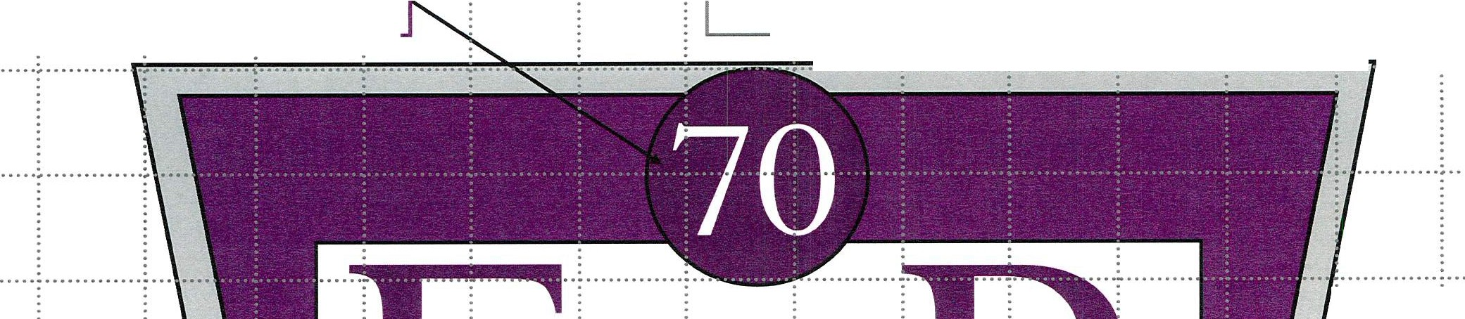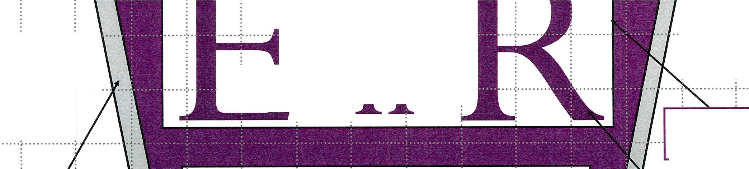

Scale 1cm = 0.25m Grid 2cm = O.Sm E. Dowthwaite March 2022
PURPL,E LOBELIA FOR LETTERING AND SURROUNDING

WTC 31/03/2022

Item 9

CHRISTMAS LIGHTS INFRASTRUCTURE

Purpose of the Report

To inform Members that 100 stainless steel U-bolts need to be exchanged for a larger size and to authorise the additional expenditure.

  - INTRODUCTION

  - The Council purchased 100 stainless steel U-bolts as part of an order for catenary wire and fittings (minute ref 1942/22 refers).

  - Unfortunately, the Lighting Contractor discovered that the wrong size U-bolt had been ordered.

  - Having contacted the supplier we have been informed that they would accept the returned U-bolts and exchange them for the correct size but that there is an additional cost of £49 + VAT.

  - RECOMMENDATION

  - To approve the exchange of the U-Bolts for the correct size and authorise the additional expenditure of £49 + VAT.

WTC 31/03/2022

Item 10

LOCAL PLAN CONSULTATION SEEKING VIEWS ON TWO POTENTIAL SITES FOR USE AS GYPSY AND TRAVELLER ACCOMMODATION

Purpose of the Report

To consider the Local Plan consultation seeking views on two potential sites for use as Gypsy and Traveller accommodation in Copeland and to make comments on this to be forwarded to CBC

  - INTRODUCTION

  - Attached at Appendix 1 is a copy of the consultation documents received from Copeland Borough Council seeking the Council's views on two potential sites for Gypsy and Traveller accommodation. The closing date of the consultation is 3rd May 2022.

  - The potential sites are land to the north of Greenbank and land at Sneckyeat which you can see from the plans attached.

  - Attached at Appendix 2 is a reduced version of The Cumbria Gypsy and Traveller Accommodation Assessment (GTAA) which relates to Copeland.

  - RECOMMENDATION

  - That Members consider the consultation document and that any representations made be passed to Copeland Borough Council

Whitehaven Town Council

7>,ty:_ (
\A..:>T C s i} {2-l

I J:E!'j ,o

From:
Sent:
To:
Subject: Attachments:
Local Plan Consultation <localp lanconsultation@copeland.gov.uk> 21 March 2022 11:43
Local Plan Consultation
Copeland Local Plan 2021- 2038: Gypsy and Traveller Site Allocation Consultation G and T Letter for Parish Councils .pdf; Public notice.pdf; G and T Consultation Poster.pdf

Dear Parish Clerk,

Please find at tached a let t er outlining a Local Plan consult at ion which see ks views on two pot ent ial sit es for use as Gypsy and Travell er accommodation in Co pe lan d. This consultation will run for six weeks until 3rd May 2022 .

Following the consu lt at ion , one ofthese sit es wi ll be added into policy H9PU of the Copeland Local Plan
2021-2038 Pu blic at ion Draft. The Pub li cat io n Dr aft is the final draft of the Local Plan , which will be
subm it t ed to t he Planning Inspe ctorat e in April 2022 for a public examination. It is then anticipated that the Local Plan will be adopted in earl y 2023.

Regar ds,

Ch ri s Hoban

Co peland - the best place to live in Cumbria This email is con fi dent ial and is for the attention of the addressee on ly. Cope land Borough Counc il accept no responsibility for information, errors or omissio n s contained in it. We make every effort to keep our netwo rk free from viruses. You should in depe ndent ly check this e-mail and any attachments for viruses, as we can t ake no responsibilit y for any computer viruses that might be t ransfer r ed by way of this e-mail.
Information Classification - UNCLASSIFIED

C o p e l an d B o ro ug h Co un ci l tel: 0 19 46 59 83 00
The Copeland Centre. email: infora)cop eland.g ov.uk Catherine Street, Whitehaven, web: w w w.cop eland .go v.uk Cumbria CA28 7SJ twitter: <a)cop elandb c

21st March 2022

Dear Parish Clerk,

Cope land Local Plan 2021-2038: Gypsy and Traveller Site Allocation for the Publication Draft
This letter is to inform you that Copeland Borough Counc il is carr yin g out a public consultation into the allocation of land for use as accommodation for Cope lan d' s Gypsy and Traveller communit y. The consultat ion will run for six weeks between 21st March and 3rd May 2022.
The Gypsy and Traveller site allocation will form part of the Cope land Loca l Plan 2021-2038. The Loc al Plan was subject to consu lt at ion between Monday 10th January and Fri day18th March 2022. At the t ime of consu lting on the Local Plan, the re was a gap at Policy H9PU for a Gypsy and Traveller sit e allocat ion, as at that time Officers were awaiting the final Cumbria Gypsy and Traveller Accommodat ion Assessment. This assessment concludes that Copeland has a requirement to make provision for 12 Gypsy and Traveller Pit ches in the borough.

Since the completion of the report, we have been working to identify a suit able sit e to accommodate the need and have subsequently found two potentially suit able sit es, both located in Whitehaven. This consultat ion t herefore asks for views and opinions on these two sit es, one of which will be allocated as a Gypsy and Traveller site under policy H9PU of the final Local Plan .

Following this consultation, the Local Plan, including the Gypsy and Travelle r sit e and all associated sub mi ssion documents will be submitted to the Secretary of State in May 2022 for Public Examinat ion by a Planning Inspector. Once the documents have been submitted, the Exam inat ion will run for the remainder of 2022, and it is hoped the Planning Inspector will produce their report in January 2023 to allow the Local Plan to be adopted in March 2023. Th e Gypsy and Trave ller consult at ion report and associated documents can be viewed
here: https://www.copeland.gov.uk/content/gypsy-and-trave11er-site-allocation-consultation.

We appreciate that not everyone has access to the int ern et and th e documents will be availab le to view at the Copeland Borough Council Offi ces, Market Hall, Whit ehaven.The consultation may also be available to view at local libraries in Copeland (Please note the opening hour s and Covid-19 restrict ions in place at Council Offices and Libraries may mean t he documents are unavailable, and you may need to book an appo intment in advance). If you have any comments on the Gypsy and Traveller Consult at ion, please complete the questionnaire online at the followin g link: https:/ / forms.office.com/ r/ 8byqA9L44B.

Alternatively you can complete a Representation Form and return it to Copeland Borough Council at the fo llowing address/ ema il:

St rateg ic Planning Copeland Borough Council The Market Hall
M arket Place Whit ehaven
Cumbria CA28 7JG

Or by email to: LocalPlanC onsultat ion@ copeland.gov.uk. Please send all responses no later than 3rd May 2022.
Yours fait hfully

'; r I
..,. t.., ..,-f,.....
i. , ' ,'-"'-"'-

Chris Hoban
Strategic Plann ing Manager

Privacy Notice
A copy of the Counc il' s privacy statement can be viewed at
https:// www.copeland.gov.uk/sites/default/files/attachments/privacy notice1.pdf. Further information is also available by contacting the council' s Data Protection Officer at info@copland.gov.uk or by calling 01946 598300 and asking to speak to the Data Protection
Officer.

Copeland Borough Council Planning and Compulsory Purchase Act 2004
Town and Country Planning (Local Planning) (England) Regulations 2012

Copeland Local Plan 2021-2038: Publication Draft Addendum for Gypsy and Traveller Site Allocation Statement of Representations Procedure
Title of Document: Copeland Local Plan 2021-2038: Publication Draft Addendum: Gypsy and Traveller Site Allocation Regulation 19 Consultation Paper
Subject Matter: This document consult s on two potential sites for Gypsy and Traveller accommodation in Copeland and seeks to allocate one site for this use. The Gypsy and Traveller site allocation w ill complete the Publication Draft of the Copeland Local Plan 2021-2038.
Area Covered: Copeland Borough outside of the Lake District National Park, with the two potential sites located in Whitehaven.

Consultation period: From Monday 21st March 2022 until 4.30pm on Tuesday 3rd May 2022

Where the documents can be viewed: The consultation documents can be viewed on the Council's website: https:// www .copeland.gov .uk/cont ent/ gypsy-and-traveIler-site-aIlocat ion-consultation.
The documents will be available to view at Copeland Borough Counci l Offices, Market Hall, Market Place, Whitehaven, CA28 7JG. Documents may also be available to view at the following libraries in the borough:
- Cleator Moor Library- Market Square, Cleator Moor, CA25 SAP
- Egremont Library-West Lakes Academy, Main Street, Egremont CA22 2DQ
- Frizington Library - Main Street, Frizington CA26 3PF
- Millom Library- St George's Road, Millom, LA18 4DD
- Whitehaven Library - Lowther Street, Whitehaven, CA28 7QZ This will be subject to opening hours and Covid-19 restrictions.
Representations : Comments shou ld be made in writing on the Representation Form and sent by email or post by no later than 4:30pm on Tuesday 3rd May 2022 to:
Email: localplanconsult ation@copeland.gov.uk

Post: Strategic Plan ning Team Copeland Borough Council Market Hall
Market Plac e Whitehaven CA28 7JG

Alt ernatively, fill out the Microsoft Forms Response form on the webpage above.

Request to be notified: Representations may be accompanied by a request to be notified at a postal address/email address of any of the follow ing:
- Submission of the Local Plan for public examination by an independent Planning Inspector;
- Publication of the Inspect or' s recommendations; and
- The adoption of the Local Plan.

Strategic Planning Team Monday 21'¹ March 2022

Copeland Local Plan 2021-2038
Gypsy and Traveller Site Allocation Consultation
Copeland Borough Council is carrying out a public consultation into the allocation of land for use as accommodation for Copeland's Gypsy and Traveller community.
Following the consultation, one site will be allocated as a Gypsy and Traveller site under policy H9PU of the Copeland Local Plan 2021-2038.
The two sites that are being considered are as follows:
  - Land north of Greenbank, Whitehaven (left image)
    - Land at Sneckyeat, Whitehaven (right image)

The Consultation runs from 21st March until 3rd May 2022

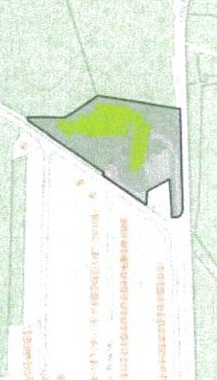
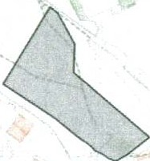
\

......., ....

For fur ther information about the consultation and next st eps, please:

Visit: https:/ / w ww.copeland.gov.uk/content/gypsy-and-traveller-sit e-aIlocati on­ consultation
Copland Boro u gh Council Office, Market Hall, Whitehaven
Email: localplan consu lt ati on @co peland.gov.u k

Call: 01946 598 300 and ask to speak to the Strategic Plann ing Team

Whitehaven Town Council

From: Sent: To: Subject:
Leanne Parr <Leanne.Par@r copeland .gov.uk> 15 March 2022 16:14
Whitehaven Town Council
Copeland Local Plan Gyp sy and Traveller Consultation

Hello,

Copeland Borough Council has a duty to meet the housing needs of all its residents, including those who identify as Gypsies and Travellers.

Earlier this year a Cumbria -wide Gypsy and Traveller Assessment was pro duced. A copy of the document can be found here: htt ps:/ / www .copeland.gov .uk/att achment s/cumbria-gt aa. The GTAA identifies a need for 12 pitches in the borough to accommodate a local resident and their family over the 2021-2038 plan period.

The Council has carried out a number of call for sites to identify a site to meet the need. As no sites have been put forward for consideration, the Council has had to consider land in its own ownership. An assessment of council owned sites has been undertaken and only two potential sites have been identified as being suitable (please see maps below). These are:

Land at Sneckyeat Industrial Estate, Whitehaven Land at Greenbank, Whitehaven

Earlier t oday, the Council agreed to start a 6 week public consultation in order to seek views on both sites which will run from 21st March to the 3rd May 2022. At the end of the consultation we will consider all responses received, as well as any new evidence available , and will select one of the two sites for inclusion as a Gypsy and Traveller site allocation in the new Local Plan. The Local Plan will then be submitted to the Planning Inspectorate for their consideration later that month.

We will send you a formal email advising of the consultation next week, however we just wanted to get in touch in advance incase you are approached by members of the public before the consultation starts. When the consultation goes live next week all supporting documents such as the assessment document and response forms will be available online. A link will be included in the email. We hope you will help us promote the consultation in due course on your social media pages as we want to encourage as many people to engage in the process as possible.

If you have any queries please let me know. Kind regards, Leanne

Leanne Parr
Principal Strategic Planner Strategic Planning Copeland Borough Council 01946 598300
07385362768
Leanne.Parr@cope land.gov.uk

Please note my working days are: Monday, Tuesday, Thursday and Frida y.

Copeland BoroughCouncli, The Copeland Centre, Catherine Street, Whitehaven, Cumbria,CA28 7SJ.Tel: 01946 598300. Fax:
01946 598303. www.copeland .gov.uk, info@co peland.gov.uk

Ord nance Survey data |  | Crown copyright and database rig ht 2022 OS  Cros n 100030994  111
Gypsy and Tra ve lle r • Co nsi d e re d Si tes  GTWSa | CopelandBoroughCouncil  The Marke t Hall Market Place Whitehaven Cumbria, CA28 7JG | Copeland
 | Date of Issue: 16/02/ 2022 | Scale: 1 : 2,500
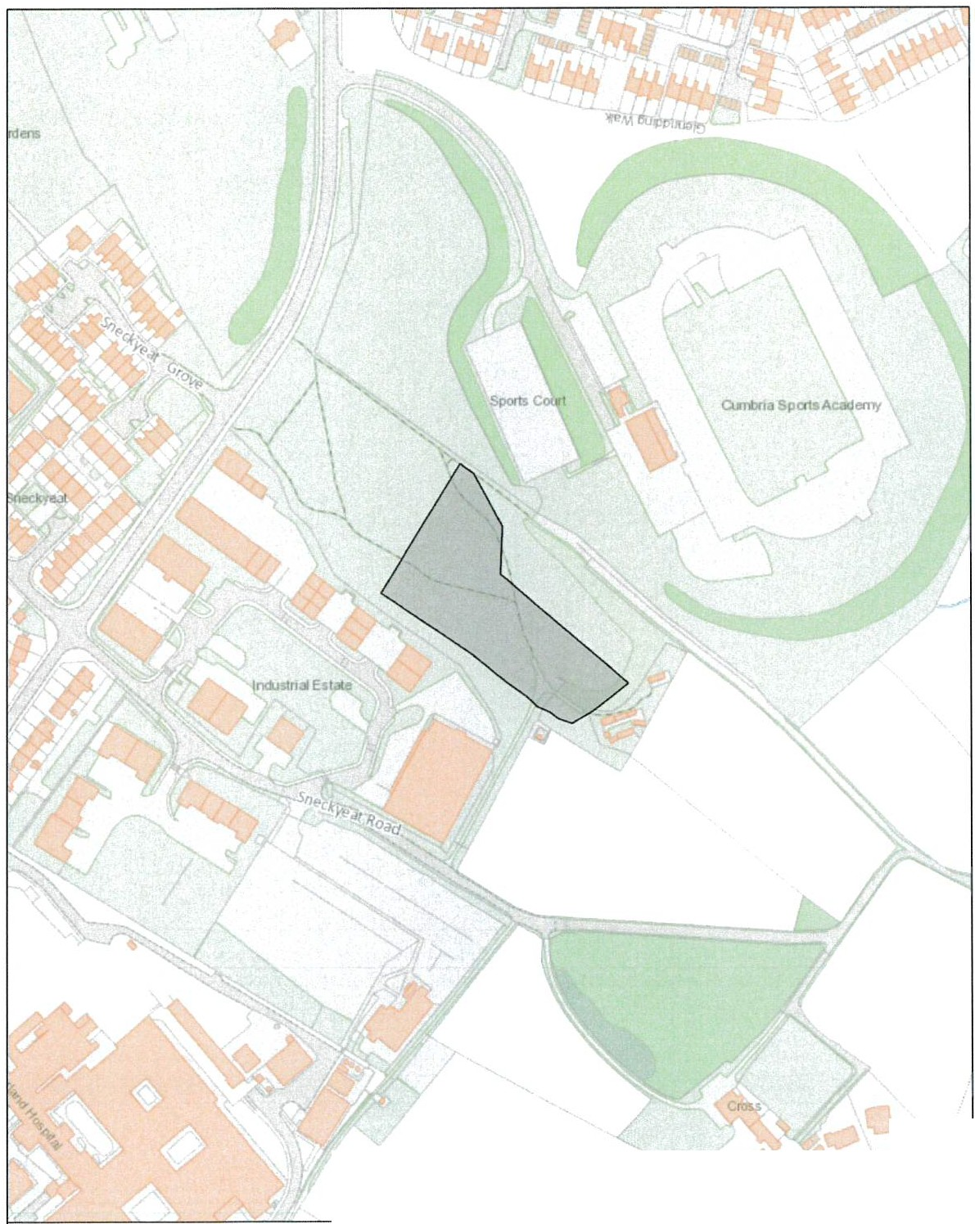
Copeland - the best place to live in Cumbria This email is confidential and is for the attention of the addressee only. Copeland Boro ugh Council accept no responsibility for information, errors or omissions cont ain ed in it. We make every effort to keep our net work free from viruses. You should independently check this e-mail and any attachments for viruses, as we can take no responsibility for any computer viruses that might be transferred by way of this e-mail.
Info rmati on Clas sifi cat ion - UN CLASSIFIED

3

fa:. Opinion Research Services
-APPeN'Dlx/_2 / ..
3
\A.)·-r-e--- 3f
22-

:==== = = = = = = = = = = = ::;z:::;:;:ae=M== ro = = =
Exce//eV\t v-esear-cl-\ Fov- tl-\e public. vo/w,tav-!:J aV\d pr-ivate sector-s

Lake Dist rict Nat ionalPark

BOROUGH OF
BARROW IN

FURNESS
----£de n
District Council

CARLISLE

www.carlisle.gov.uk

YORKSHIRE DALES
c;;.;::
Na tional Park Auth orit y

Cumbria
Gypsy ana Iraveller Accommoclation Assessment (GTAA)

Final Report January 2022

Opinion Rese arch Services I The Str and • Swan sea • SAl lAF I 01792 535300 I www .or s.org .uk I info @ors.org .uk

Opinion Research Services I Cum br ia GTAA - Fina l Re po rt I January 2022

Opinion Research Services I The Strand , Swansea SAl lAF Steve Jarman , M ichael Bayliss, Gill Craddock, and Lee Craddock enquiries: 01792 535300 · in fo@or s.org .uk · www.ors.org.uk

© Copyright January 2022

Con tains public sector inform ation licensed under the Open Government \Licence v 3.0 May contain OS Data © Crown Copyright (2022)

Opinion Research Serv i ces I Cumbria GTAA - Final Report I January 2022

Contents
- Ex ecut ive Summary 8
Int roduction and M ethodology 8
Key Finding s 8
Pit ch Needs - Gypsies and Travellers 8
Alle rdale 9
Barrow -in-Furnes s 10
Carl isle 10
Co pe land 11
Ed en 11
South Lakeland (excluding National Parks) 12
Lake Distri ct Nati o nal Park 12
Yo rk shire Dales Nation al Park 12
Plo t Needs - Travelling Show p eople 12
All erdale 13
Barr ow -in-Furnes s 13
Carli sle 13
Cop eland 14
Eden 14
South Lakeland (excluding National Parks) 14
Lake District National Park 14
Yo r kshire Dal es National Park (Cumbria) 15
Transit Recommendati on s 15
- Introduct ion 17
The Study 17
Defi nitions 17
The Plann ing Defi nition in PPTS (2015) 17
Definit ion of Travelling 18
Legislation and Guid ance for Gypsi es and Travellers 20
Pl anning Policy for Traveller Sites (PPTS) 2015 20
Revised Natio nal Planning Poli cy Framework (2021) 21
Planning for the Futu re W hi te Pap er (2020) 22
- Methodology 23
Background 23
Glossary of Terms/Acronyms 24
Desk-Based Review 24
St akeholder Engagement 24
Working Collaboratively with Neighbouring Planning Authorities 24

Opinion Research Services I Cumb ria GTAA - Final Re port I Janu ary 2022

Survey of Travelling Communit ies 24
St age 1 - Teleph one Int erview s 25
Stage 2 - Social Distanced Engagement 25
Engagement with Bricks and M ortar Households 26
Tim ing of th e Fieldwork 26
App lying the Plann ing Definit ion 26
Undetermin ed Households 27
Househo lds that do not meet the Planning Definition 28
Calculating Current and Future Need 29
Supp l y of Pi tches 29
Curren t Need 30
Future Need 30
Pit ch Turnover 30
Transit Prov ision 31
- Gypsy, Traveller and Travelling Showpe ople Sites and Population 33
Int r odu cti on 33
DLUHC Traveller Caravan Cou nt 34
- Current and Future Provision 35
Background 35
New Household Formation Rates 35
Breakdown by 5 Year Bands 37
App lying the Planning Definit ion 37
Public/Private Split 37
M igration 38
- GTAA Outcomes 39
Cum br ia Summary 39
- Allerdale Borough Council (excludingNational Parks) 41
Sites and Yards in the St ud y Area 41
Stakeholder Engagement 41
Intervi ews with Gypsies and Travellers 43
Brick s and Mortar Interviews 44
M igrati on/ Ro adside 44
Pitch and Plot N eeds 44
Pitch Needs - Gypsies and Travel lers that met the Planning Definition 45
Pit ch Needs - Undetermined Gypsies and Travellers 46
Pitch Needs - Gypsies and Travellers that did not meet the Planning Defi nition 46
Travelling Showpeople Needs 47
Plot Needs - Travelling Sho w p eople 47

Opinio n Research Services I Cum br ia GTAA - Final Repo r t I January 2022
Pit ch Needs - Undet ermined Travelling Sho w p eople 48
Pit ch Needs - Travelling Showpeople that do not meet the Planning Definition 48
Con clu sion s 48
Gypsies and Traveller s 48
Travelling Sho wpeople 49
- Borough of Barrow-in-Furness 50
Sit e s and Yards in th e Study Area 50
Stakeholder Eng agement 50
Int erviews with Gypsies and Travellers 51
Bricks and M ort ar Int erviews 52
Pit ch and Plot Needs 52
Pit ch Needs - Gyps ies and Travellers th at met the Plannin g Definition 53
Pitch Needs - Undet ermined Gyps ies and Travellers 54
Pit ch Needs - Gypsies and Travellers tha t did not m eet the Plan n in g Definition 54
Travelling Sho wpeople Needs 55
Plot Needs - Travell ing Showpeople 55
Conclusions 55
Gypsies and Travellers 56
Travelling Sh o wpeople 56
- Carlisle City Council 57
Sites and Yards in the Study Ar ea 57
Stakeho lder Eng agement 57
Int erviews wit h Gypsies and Traveller s 59
Pit ch and Plo t Needs 60
Bricks and Mortar Interviews 61
Pitch Needs - Gypsies and Travellers that met the Plann ing Definition 61
Pitch Needs - Undet ermined Gyp sies and Traveller s 62
Pitch Needs - Gypsi es and Traveller s th at did not meet the Plann ing Definition 63
Travelling Showpeople Needs 63
Plot Needs- Travelling Sho wpeople 63
Conc lusion s 64
Gypsi es and Travellers 64
Travelling Showp eople 66
- Copeland Borough Council (excluding National Par ks) 67
Sit es and Yards in the Study Area 67
St ake holder Engagement 67
Accommodat i on for Gypsies and Travellers 67
Short-term Roadside En campments and Transit Provision 68
Cro ss-Boundary lssues 68
Intervi ews with Gyp sie s and Travellers 68

Opinion Research Services I Cumbria GTAA - Final Report I January 2022

Pitch and Plo t Needs 69
Bricks and Mo rt ar/ Waiti ng List Interviews 69
Migrat ion/ Roads ide 69
Conclus ion s 71
Gypsies and Travellers 71
Travelling Sho wpeople 72
- Ed en Dist ri ct Coun cil (excludin g Nat io nal Parks) 73
Sites and Yards in the Stu dy Area 73
Sta keholder Engagement 73
Accom modat i on for Gypsies and Travellers 73
Short -t erm Roadside En campments and Transit Provision 73
Cro ss-Boundary Issues 74
Int erviews with Gypsies and Travellers 74
Pitch and Pl ot Nee ds 74
Brick s and Mort ar/ Waiting List Int erv iews 75
Conclusions 77
Gypsies and Travellers 77
Travelling Showpeople 78
- So ut h Lakeland Dist r ict Co un cil (exclu ding Nat ional Par ks) 79
Sites and Yards in the St u d y Ar ea 79
St ake holder Engagement 79
Int erviews wit h Gyps ies and Travellers 81
Pit ch and Plot Needs 81
Bricks and M ort ar 82
Concl usions 84
Gypsies and Travellers 84
Travelling Showpeopl e 85
- Lake Dist rict Nat ional Park Aut ho rit y 86
Sites and Yards in the Study Area 86
St akeh older Engageme nt 86
Accommodation for Gypsies and Traveller s 86
Short -term Roadside Encampments and Transit Provis ion 87
Cro ss-Boundary Issues 87
Int erviews wit h Gypsies and Travellers 87
Conclusions 89
Gypsies and Travellers 89
Travelling Showpeople 90

Opinion Research Services I Cumbria GTAA - Final Report I January 2022

- Yo r kshir e Dales National Park (Cumbria) 91
Sites and Ya r d s in the Study Area 91
Stakeho l d er Engagement 91
Interview s with Gyps ies and Travel lers 92
Conclus io ns 94
Gypsies and Tr avellers 94
Travelling Sho wpeop le 95
1 5. Transit Requirements - All Local Aut h orit ies 96
Introdu ct io n 96
Ident ifyi n g Transit Requirements 97
Stake holde r lnt ervi ew s 97
DLUHC Trav eller Caravan Count 99
Transit Re co m m end at io ns 99
List of Figures 101
Append ix A: Glossary of Term s 107
Appendix B: Need from Undetermined House h o lds 109
Appendix C: Need from house h olds not m eet ing Plann ing Defi nit io n 125
Appendix D: Neighbouring Aut hor ity lnterviews 141
Append ix E: Site and Yard Lists (September 2021} 146
Append ix F: Household Interview Questions 154
Appendi x G: ORS Technical Note on Gyp sy and Traveller Househo ld Formation and Growth Rates 163

Opinion Research Services I Cumbria GTAA - Final Report I January 2022

1. Executive Summary
Introduction and Methodology
11 The primary objective of this Gypsy, Traveller and Travelling Showpeople Accommodation Assessment (GTAA) is to provide a robust assessment of current and future need for the Cumbria planning authorities of Al lerdale, Barro w-in-Furn ess, Carl isle, Copeland, Eden, South Lakeland, and the Lake District National Park, as well as areas of the Yorkshire Dales National Park Authority (YDNPA) that lie in Cumbria.

12 The GTAA provides a credible evidence base wh ich can be used to aid the preparation and implementation of Local Plan Policies and the provision of new Gypsy and Traveller pitches and Travelling Showpeople plots for the 15-year period up to 2035, as req uired by the PPTS, and to 2040 to meet Local Plan Periods. The outcomes of this study supersede the need figures of any previous Gypsy, Traveller and Travelling Sho wpeople Accommodation Needs Assessments completed in the study area.

u The GTAA has sought to understand the accommodation needs of the Gypsy, Traveller and Travelling Showpeople population in the study area through a combination of desk-based research, stakeholder in terview s and engagement with members of the Travelling Community living on all identified sites and yards. A tot al of 82 interviews were completed with Gypsies and Travellers and 36 interviews were completed with Travell ing Showpeople living on authorised and unauthorised sites and yards. Following efforts to identify households living in bricks and mortar it was possible to identify 5 households to interview. In addition, stakeholder engagement was undertaken and total of 27 telephone interviews were com pleted.
14 The fieldwork for the study was completed between November 2020 and September 2021. The baseline date for the study is September 2021 which was when the site interviews were completed.

15 A Glossar y of Terms can be found in Appendix A.

Key Findings

Pitch Needs - Gypsies and Travellers
16 Overall, t he pitch needs for Gypsies and Travellers from 2021-2040 are set out below. Needs are set out for those households that met the planning definition of a Gypsy or Traveller; for tho se undetermined households1 where an interview was not able to be completed (either due to site owners refusing access on to sites, individual households refu sing to be interviewed, or households not being present despite 3 visits to each site or yard) who may meet the planning definition; and for those households that did not meet the planning definition - although this is no longer a requirement for a GTAA.

u Only the need from those households who met the planning de finit ion and from those of the undet ermined households who may subsequently demonstrate that they meet it should be considered as need arising from the GTAA.

1 See Paragraph 3.28 for further information on undetermined households.

Opinion Research Services I Cumbria GTAA- Final Report I January 2022

1.a The need arising from households that met the planning definition should be addressed through site allocation/intensification/expansion Local Plan Policies .
19 The Councils will need to carefully consider how to address the needs associated with undetermined Travellers as it is unlikely that all of this need will have to be addressed through the provision of conditioned Gypsy or Travell er pitches. In terms of Local Plan Policies, the Councils should consider the use of a criteria -based policy (as suggested in PPTS) for any undetermined households, as well as to deal with any windfall applications.
110 In general terms, the need for those households who did not meet the planning de finit ion will need to be addressed as part of general housing need and through separate Local Plan Policies. This approach is specifically referenced in the revised National Plann ing Pol icy Framework (July 2021). Paragraph 61 of the NPPF sets out that in determining the minimum number of homes needed, strategic plans should be based upon a local housing need assessment conducted using the standard method in national planning guidance. Paragraph 62 then states that [emphasis added] 'Within this context, the size, type and tenure
of housing needed for different groups in the community should be assessed and reflected in planning
policies (including, but not limited to, those who require affordable housing, families with children, older people, students, people with disabilities, service families, travellers, people who rent their homes and people wishing to commission orbuild their own homes'. The footnote to this section states that ' Planning Policy for Traveller Sites sets out how travellers' housing needs should be assessed for those covered by the definition in Annex 1 of that document.'

¹¹¹ It is recognised that the Councils are in the process of reviewing their Local Plans. As the plans are reviewed the findings of this report should be considered as part of future housing mix and type within the context of the assessment of overall housing need in relation to Gypsies, Travellers and Travelling Showpeople. Whilst the findings in this report are aggregated totals for each local authority due to data protection issues, the Councils have more detailed data to enable accurate Local Plan allocations to be made.

Allerdale
1.1 2 There were 11 Gypsy or Traveller households identified in Al lerdal e that met the planning definition, no undetermined households that may meet the planning definit ion, and 2 households that did not meet the planning definition.
1.13 The GTAA identifies a need for 14 pitches for households that met the plann ing definition . This is made up of 6 unaut hor ised pitches on encampments; 3 concealed or doubled-up households or single adults living on the encampments; and for 5 from new household formation, derived from the household demographics²
•
¹¹⁴ It should be noted that all of this need was from households living on long-term unauthorised encampments in Allerdale and none of the households expressed a wish to move to a public site due to personal circumstances including scrap metal dealing and the keeping of livestock. All are looking to purchase or rent land to develop private family sites.

115 There is a no need for undetermined households as interviews were completed with all Travellers who were identified on unauthorised encampments at the time of the assessment.

2 Further information of how new household formation rates have been calculated can be found in Chapter 5 .

Opinion Research Services I Cumbria GTAA - Final Report I January 2022

1.1 6 Whilst not now a requirement to include in a GTAA, there is a no need for househ olds that did not meet the planning definition as both households are seeking to mov e to bricks and mortar in the local area.

Figure 1- Need for Gypsy and Traveller households in Allerdal e 2021-2040

Status 2021-40
Meet Planning Definition | 14
Undetermined | 0
Do not meet Planning Definition | 0

Barr ow-in-Furness
117 There were 6 Gypsy or Traveller households identified in Barrow-in-Furness that met the planning definition, no undetermined households that may meet the planning definition, and 8 households that did not meet the planning definition.
¹¹⁸ The GTAA identifies a need for 5 pitches for hou seholds that met the planning definition. This is made up of 3 pitches for teenagers who will need a pit ch of their own in the next 5 years, and 2 pitches from new household formation, derived from the demographics of the residents.

1.1 9 It was noted during the household interviews that the residents on the private site are living there on a week-to-week basis with the permission of the site owner and therefore have no security of tenancy. Should the site owner seek to sell the land need could increase by a further 5 pitches. It is understood that the current residents are in the process of identifying suitable land to develop a new site in Barro w­ in-Furn essshou ld their tenancies be terminated. The Council are aware of this.

120 It was possible to complet e int erview s with all identified Gypsies and Travellers living on sites in the Boro ugh of Barrow-in-Furness so there were no undetermi ned households. Anecdotal evidence and past planning permissi ons for r esid ential caravans suggest that there have been a small number of Gypsies and Travellers that have ceased to trav el and now reside in permanent residential caravans within the borough .

12 1 Whilst no longer a requ ir ement to include them in a GTAA, there is a need for 6 pitches for households that did not meet the planning definition. This is made up of 1 concealed or doubled-up household or adult; 3 teenagers who will be in need of a pitch of their own in the next 5 years; and 2 from new household formation derived from the household demographics.

Figure 2 - Need for Gypsy and Traveller households in Barrow-in -Furn ess2021-2040

Status | 2021-40
Meet Plann ing Definition | 5
Undetermined | 0
Do not meet Planning Definition | 6

Car li sle
1.2 2 There were 39 Gypsy or Traveller households identified in Carlisle that met the planning definition, 8 undetermined households that may meet the planning definition, and 10 households that did not meet the planning definit ion.
123 The GTAA identifies a need for 33 pitches for households that met the planning definition, and this is made up of made up of 4 unaut ho rised pitches; 5 concealed or doubled-up households or adults; 3

Opinion Research Services I Cumbria GTAA - Final Report I January 2022

teenagers in need of a pitch of their own in the next 5 years; 5 pitches from in-migration/roadside; and 16 from new household formation derived from the household demographics.

124 The GTAA identifies a need of up to 3 pitches for undetermined households and this is made up of new household formation of up to 3 from a maximum of 8 households. If the ORS national average of 30% were applied this could result in a need for 1 pitch. If the local proport ion of households that met the planning definition (80%) is applied this could result in a need for 2 pitches.

125 Whilst no longer a requirement to include them in a GTAA, there is a need for 3 pitches for households that did not meet the planning definition. This is made up of 3 from in-migration/roads ide.

Figure 3 - Need for Gypsy and Travell er households in Carlisl e 2021-2040

Status 2021-40
Meet Planning Definition | 33
Undetermined | 0-3
Do not meet Planning Definition | 3

Cope land
1. 2G There were 6 Gypsy or Traveller households identified in Copeland that met the planning definition, no undetermined households that may meet the planning definition, and no households that did not meet the planning definition .
1 27 The GTAA ident ifies a need for 12 pitches for households that met the planning definition. This is made up of 1 household seeking to move from bricks and mortar and develop a private family site; 5 from roadside/in-migration; 1 concealed or doubled-up adult; 3 teenagers who will be in need of a pitch of their own in the next 5 years; and 2 from new household formation derived from the demographics of the households that were interviewed.

Figure 4 - Need for Gypsy and Tr aveller households in Copeland 2021-2040

Status 2021-40
Meet Planning Definition | 12
Undetermined | 0
Do not meet Planning Definition | 0

Eden
128 There were 5 Gypsy or Traveller households identified in Eden that met the planning definit ion, no undetermined households that may meet the planning definition, and 8 households that did not meet the planning definition .
129 The GTAA identifies a need for 1 pitch for households that met the planning definition, and this is made up of 1 temporary pitch. It should be noted that this site has a temporary planning consent until October 2032.
uo Whilst no longer a requirement to include them in a GTAA, there is a need for no pitches for households that did not meet the planning definition.

Opinion Research Services I Cumbria GTAA- Fin al Report I January 2022

10. Copeland Borough Council (exclt1ding National Parks)

Sites and Yards in the Study Area

10 1
·
In Copeland, at the baseline date for this study, there were no Gypsy and Travellers sites and no Travelling Showmen's yards. Furt her details can be found in Appendix E.

Figure 39 - Total amount of provision in Copeland (September 2021)

, Status | Sites/Yards Pitches/Plots
Pri vate sites with permanent planning permission |  | 0 | 0
Private sites with temporary planning permission |  | 0 | 0
Public site s (Council and Registered Providers) |  | 0 | 0
Public transit provision |  | 0 | 0
Private transit provision |  | 0 | 0
Tolerated sites |  | 0 | 0
Unauthorised sit es |  | 0 | 0
Travelling Showpeople yard s |  | 0 | 0
TOTAL |  | 0 | 0

Stakeholder Engagement
10·2 ORS u ndertook a stakeholder engagement programme to complement the informatio n gathered through interviews with members of the Travelling Community. This consultat ion took the form of telephone interviews which were tailored to the role of the individual. The aim of these interviews is to provide an understanding of curren t provision and possible fut ur e need; short-term encampments; transit provision; and cross-border issues.

10 3 An interview was undertaken wit h 2 Council Officers in Cop eland. Due to issues surrounding data protection, and in order to protect the anonymity of those who took part, this section presents a summary of the views expressed by interviewees and verbatim comments have not been used. The narrative represents a balanced summary of the views of the individual concerned, rather than the official policy of th e Coun cil.

Acco mmodat ion for Gypsies and Travellers
l0.4 Copeland have produced the Local Plan 2021-2038 Publication Draft that makes a commitment to meeting the needs of the Gypsy, Traveller and Travelling Showperson community and states that Copeland will identify a suitabl e site should a need be identi fied.
¹⁰·5 The Council are aware of potentia l need arising from a family currently living in bricks and mortar housing in the ar ea.

Opinion Research Services I Cum bria GTAA - Final Report I January 2022

Short-term Roadside Encampments and Transit Provision
10·6 For the small number of encampments that would ever st ay in the borough it was not believed that any form of tr ansit p ro vision is necessary.

Cross-Boundary Issue s
10 ·7 No specific cross bor der issues we re identified

108 Copeland Council have a good relat ionship with neighbouring author ities and will engage wit h them through the Duty to Coope rat e when producing the emerging plan. Cross bo undary issues such as how best to meet t raveller needs will be discussed at this st age.

Int erviews with Gypsies and Travellers
10·9 One of the major compo nent s of this study was a deta iled su rv ey of the Gypsy, Travel ler and Travelling Showp eople populat ion liv ing on sites and yards in the study area . This aimed to identify current households with housing needs and to assess li kely futu re housing need from within exist ing ho useholds, to he lp judge the need for any fut ure pitch provision. The household interview quest i ons can be found in Appendix F.

10 10 Thro ugh the desk-based research and stakeholder interviews ORS sought to identify all authorise d and unauthor ised sites and yards in the stu dy area. The sit e lists were agreed with the local aut h ori t y and can be found in Appendi x E. Int erviews were completed between November 2020 and September 2021. Up to 3 attem pts were made to interview each househo ld where they were not present when inte rviewers visited. The tables below identify the sites tha t ORS staff visited during the course of the fi eldwork, and also set out the number of interviews that were completed at each site, together with the reasons why interviews were not completed and reasons why any addit i on al interviews were com ple t ed.

Figure 40 - Sites and yards visited in Co pe la nd
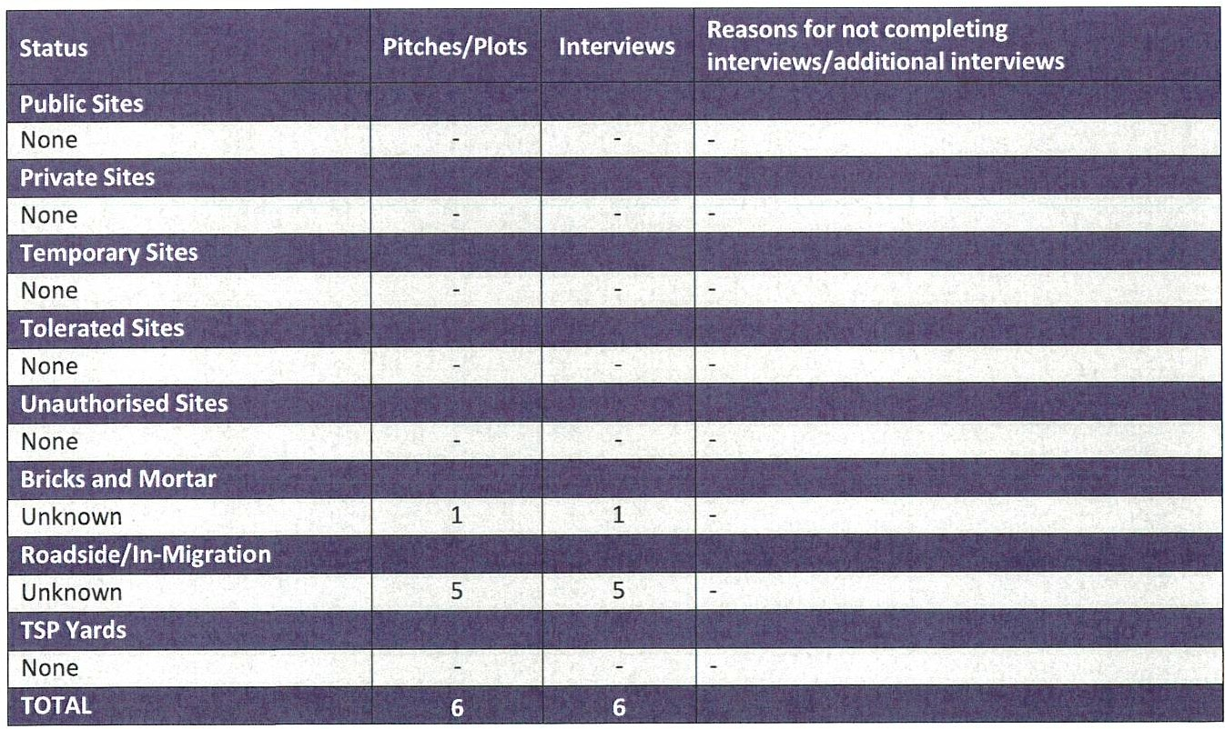

Opinion Research Services I Cumbria GTAA- Final Report I January 2022

Pitch and Plot Needs
10.11 Information that was sought from households where an interview was completed allowed each household to be assessed against the planning definition of a Traveller. This included information on whether households have ever travelled; why they have stopped travelling; the reasons that they travel; and whether they plan to travel again in the future. The table below sets out the planning status of households that are in Cope land .
Figure 41- Pl anning status of households in Cope l and

Meet Planning Does Not Meet Undetermined

Status D e mt1on
fi . .
.
f" ..
PIannmgD e m1t1on

Gypsies and Travellers
Publ ic Sites
Private Sites
Bricks and Mortar | 1 | 0 | 0
Roadside/In-Migration | 5 | 0 | 0

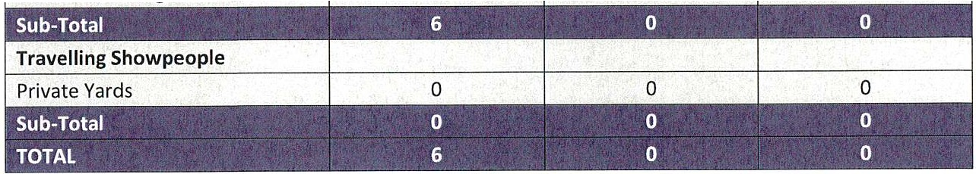
10.12 Figure 41 shows that for Gypsies and Travellers 6 households met the planning definition of a Traveller
- in that they were able to provide information that they travel for work purposes and stay away from their usual place of residence or have ceased to travel temporarily.
10·13 No households did not meet the planning defi nit ion, and there were no undetermined households.

Bricks and Mortar/Waiting List Int erview s
10 1 4The 2011 Census recorded 5 households in Co peland li ving in a house or flat that identified as Gypsy or Irish Traveller .
10 15Following all of the work that was undertaken to identify households living in bricks and mortar, it was possible to identify one households to interview.
10·161n addition, no further household in bricks and mortar are known to have approached the Council dur ing the GTAA study period seeking a site and none have declared themselves home less. As such it is fair to conclude that no further allowances should be made for bricks and mortar households - other than that from those that were interviewed - because no others identified themselves as being in need.

Migration/Roadside
10·17The household interviews identified a total of 5 households who were related to the household interviewed living in bricks and mortar who are currently travelling away for work or travelling around Cumbria seeking places to stop as they have no permanent accommodation. They are all in need of permanent accommodation in the Copeland area .

Opinion Research Services I Cumbria GTAA - Final Report I Jan uar y 2022

Pitch Needs - Gypsies and Travellers that met the Planning Definition
10·18 The households who met the planning definition of Travelling were living in bricks and mortar and on the roadside. Analysis of the household intervi ewsindicated that they would like to purchase or lease some land in Copeland to develop a small prjvate site. There was no other current or future need identified.
¹⁰·19 The GTAA identifies a need for 12 pitches for households that met the planning definition . This is made up of 1 household seeking to move from bricks and mortar and develop a private family site; 5 from roadsid e/in-migrat ion; 1 concealed or doubled-up adult; 3 teenagers who will be in need of a pitch of their own in the next 5 years; and 2 from new household formation derived from the demographics of the households that were int erviewed.

Figure 42 - Need for Gypsy and Traveller households in Copeland that met the Planning Definition 2021-2040

Gypsies and Travellers - Meeting Planning Definition | Pitches
Supply of Pitches
Supply from vacant public and private pitches | 0
Supply from pitches on new sites | 0
Pitches vacated by househ olds moving to bricks and mortar | 0
Pitches vacated by households moving away from the study area | 0
Total Supply | 0
Current Need
Households on unauthorised developments | 0
Households on unauthorised encampments | 0
Concealed households/ Doubling-up/ Over-crowding | 1
Movement from bricks and mortar | 1
Households on waiting lists for public sites | 0
Total Current Need | 2
Future Need
5 year need from teenage children | 3
Households on sites with temporary planning permission | 0
In-migration/ Roadsid e | 5
New household formation | 2
{No household formation)
Total Future Needs  Net Pitch Need= (Current and Future Need -Total Supply) | 10  12

Figure 43 - Need for Gypsy and Travell er households in Copeland that met the Planning Definit ion by year periods
10 1 1 0 12

Trav elli ng Showpeople Needs

Plot Needs - Travelling Showpeople
10·20 There were no, ravelling Showp eople identified in Copeland so there is no current or future need for plots.

Opinion Research Services I Cumbria GTAA - Final Report I Janu ary 2022

Figure 44 - Need for Travellin g Showpeople househol ds in Copeland that met the Plannin g Definition 2021- 2040

Travelling Showpeople - Meeting Planning Definition | Plots
Supply of Plots
Supp ly from vacant public and private plots | 0
Supply from plots on new yards | 0
Plots vacated by households mov ing to bricks and mortar | 0
Plots vacated by households moving away from the study area | 0
Total Supply | 0
Current Need
Households on unauthori sed developments | 0
Household s on unauthorised encampments | 0
Concea led househo lds/ Doub ling -up/ Over-crowding | 0
Movement from bricks and mortar | 0
Households on waiting lists for public yards | 0
Total Current Need | 0
Future Need
5 years need from teenage children | 0
Household s on yards with temporary planning permission | 0
In-migration | 0
New household formation | 0
(No Travelling Showpeople)
Total Future Needs  Net Plot Need = (Current and Future Need - Total Supply) | 0  0

Figure 45 - Need for Travelling Showpeople households in Copeland that met the Planning Definition by year periods
0 0 0 0 0

Conclusions
10 21This study provides a robust evidence base to enable th e Counc il to assess the hous ing needs of th e Travelling Community as well as com plying with their requirement s towards Gypsies, Travellers and Travelling Showpeople under the Housing Act 1985, Pl ann ing Policy for Traveller Sites (PPTS) 2015, the Hou sing and Planning Act 2016, the revised National Plan ning Poli cy Framework (NPPF) 2021, and Planning Practice Gui dance (PPG) 2021. It also provides the evidence b ase which can be used to suppor t Local Plan Polici es.

Gypsies and Travellers
10 2'i l n summary th ere is a need for 12 pitches in Copeland over th e GTAA period to 2040 for Gypsy and Traveller households that met the planning definiti on; a need for no pitches for undete rmined Gypsy and Traveller households that may meet the planning definition; and a need for no pitches for Gypsy and Traveller households who did not meet the planning definition .
10 23The househ old that was interviewed is curren tl y living in bricks and mortar and is seeking to purchase or lease land to develop a private fami ly sit e.

Opinion Research Services I Cumbria GTAA- Final Report I January 2022

10 24 The Council will need to careful ly consider how to address any needs from households seeking to mov e to Copeland (in-migration), or from any additional households currently living in bricks and mortar who have not presented themselves through this Study but who may wish to move to a site. In terms of Local Plan Policies, the Council should consider the use of a criteria-based policy (as suggested in PPTS).

Travelling Showpeople
10 25 There were no Travelling Showpeople ident ifi ed in Copeland so there is no current or future need for plots.

WTC 31/03/2022

Item 11

REPLACEMENT OF COMPOST DUE TO INFESTATION OF VINE WEEVIL

Purpose of the Report

To inform Members that a number of our planters and wooden barrels have been infested with vine weevil and the preventative measures required to combat the problem.

  - INTRODUCTION

  - The Council's Rangers have reported that ten large planters and eleven wooden barrels have been infested by Vine Weevils (a variety of beetle and a native pest).

Vine Weevil attack a wide range of plants including primulas, begonias and polyanthus and particularly those in planters and tubs.

Following advice from our plant supplier, the best cause of action is prevention and to:

    - Remove the top inches of compost from the affected planters/tubs;
    - Remove all roots:
    - Replace the compost.

The cost of the replacement compost is not known at the time of writing this report but will be reported to Full Council.

  - RECOMMENDATION

  - To note the information contained within the report and to approve the action to be taken and in doing so authorise the expenditure required.

WTC 31/03/2022

Item 12

IN CUMBRIA ADVERTISING

Purpose of the Report

To inform Members of an approach from IN Cumbria asking if we would like to take advantage of an advertising package and to make a decision on this.

  - INTRODUCTION

  - The Council has received an approach from In Cumbria giving details of their advertisement package and costs (see Appendix 1).

  - The cost for a half page one off Advert is £219 plus VAT and this decreases with the number of adverts purchased for a year as follows :-

2 to 3 adverts at £191plus VIAT = £573 plus VAT 4 to 7 adverts at £169 plus VAT= £1183 plus VAT
9 to 11 adverts at £147 plus VAT = £1617 plus VAT 12 adverts at £125 plus VAT=£1500 plus VAT

  - The council currently has a contract with The Guide for this year which is published every two months with a full page spread and costs £3690.00

  - However In Cumbria is different from The Guide as it the only glossy magazine in the County and it goes to and features everyone in retail including BAE submarine yard.

  - Marketing is multi-faceted and the Council needs to get to as many people as possible via as many means as possible and one of the advantages is that IN Cumbria tends to be approved to be read in magazine form and online by office

workers during office hours where the workers are generally allowed to use linkedin social media but not facebook.

  - In addition to appealing to staff and business owners the Council is trying to build up our sponsor partners to help carry the costs of events and in order to do that we need to be seen as an asset to the business community.

  - In Cumbria have also said that it will be possible to do editorials for the Council and have contact with journalists if we want anything.

  - In Cumbria is published at the beginning of every month and it is suggested that we take out 3 adverts in May, August and September so as to cover all our events for this year. This will cost £573 plus VAT

  - RECOMMENDATION

  - That members consider whether or not to purchase adverts in IN Cumbria and if so
  - To consider how many adverts to purchase and for what months

D-AY--1
WTe- 5l ls( 2, ·2_
+r?M
Whitehaven Town Council l ::L....
To: Caroline Dean
Subject: RE: FAO MARLENE - in-Cumbria Business Magazine - Engagement Opportunities

From: Caroline Dean <caroline. dean @loca liq.co. uk>
Sent: 11 March 2022 14:00
To: Whitehaven Town Counc il <Clerk @whit ehaventow ncouncil.co.uk >
Cc: Gerard Richardson MBE <gerard @ri chardsonso ff ice.net>
Subject: FAO MARLENE - in-Cumbria Business Magazine - En gagement Opportunities Hi Marlene,
Hope all is we ll with you & are having a good week.

As you will be fully aware we have a num ber of platfo rm s & opportunities within our Newsquest Cum bri a umbrella. One of which is the County's flagship B2B Magazine in-Cumbria alon g wit h our dedicat ed website in­ Cumbr i a.com.

We continue to help & support our valuable partners & of course businesscommunity, especially in the light of the past 2 years & as we commence t he recovery & build our post pandemic pipeline.

In-Cumb r ia offers that platform to engage w it h t he business community, reaching over 46,000 combined readers via the M agazine, in-Cumbria AM -new sletter along with our in-cumbria.com website . Thought it would be really useful to share th e att ached st atis ti cs w h i ch show the audience & reach. Belo w is the link that will take you straight to the lat est ed ition of in-Cumbria Magazine the March 2022 one.

htt ps:/ / www.in-cumbria.com/ magazin es/

More than happy to of course discuss the above opport unities in more detail & I would really welcome the opport unity to do so.

Thank you, Warmest of wishes,

Caro line

Caroline Dean
Business Development Manager - Partnership
Newsquest Media Group I LOCALiQ

07753 811684
newsquest. co.uk I localiq.co.uk

Whitehaven Town Council

From: Sent :
To :
Subject: Attachments:
Caroline Dean <caroline.dean@localiq.co.u k> 16 March 2022 09:53
Whitehaven Town Council
FW: FAO MAR LENE - in- Cumbria Business Magazine - Engagement Opportunities Half Page Advert Details & Costs
Digital Audience Profile.pptx; Audience Profile.pptx; in-Cumbria Master.pptx

Good Morning Marlene,

Thank you so very much once again for your time this morning & taking my call when I rang to pick up about our in­ Cumbria Magazine adv ertising opportunity.

As promised I have re-attached our aud ience reach & profi le information. It also highlights our total combined audience engagement reach is 46,000 Plus.

In terms of costs, please find below an out line of options which I have based on the half page advert. However I have also attached our interim in-Cum bria media pack that highlights the other sizes of adverts, i.e. a full page & outlines the discount for multiple bookings.

Here is the half page costs for the here & the now ahead of your Council meeting.

-Based on a Half Page advert
-5,000 digital display imp ressions

COST S
-One off advert - £219 (+vat)
-Book 2 to 3 publications £191 (+vat) per month, per edition
-Book 4 to 7 publications £169 (+vat) per month, per edition
-Book 9 to 11 publications £147 (+vat) per month, per edition
-Book 12 months so a year campaign £125 (+vat) per month, per edition

Please do not hesitat e to let me know if you need any furt her information ahead of your meeting. Thank you so very much once again Marlene & I look forward to hearing ba ck from you again.
Warmest of wishes,

Carolin e

Caroline Dean
Busi ness Developme nt Manage r - Partnership
Newsquest Media Group I LOCALiQ

07753 811684
newsquest.co.uk j loca liq .co.uk

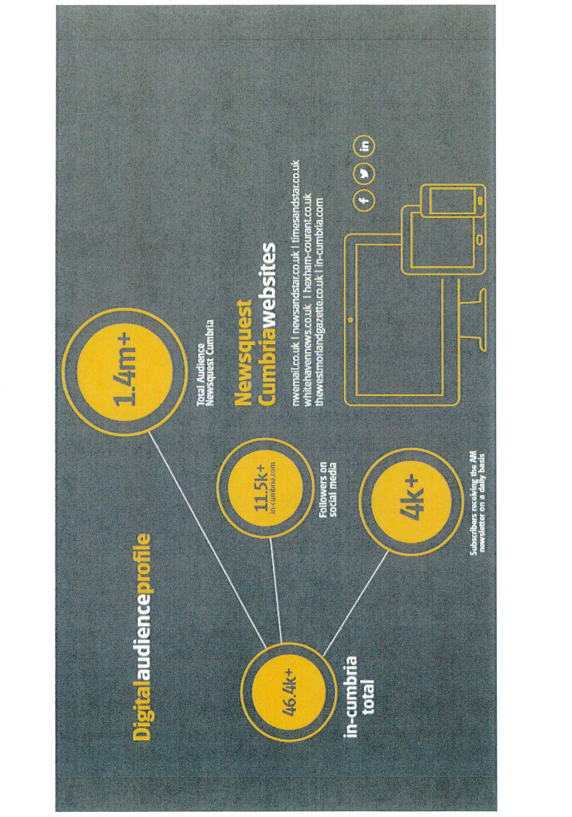

die profile
Reader demographic and subscriber information

ReadM. of in-rumbria are highly influential within the
( um bn an b lJSlfle5s matb!t,. with the majority employed 1n management or senior management positions across b!y mdusny sectors.
86% manag {!nrnnt profossio na ls
of our aud1ell( C!! am
intlue nttal senior

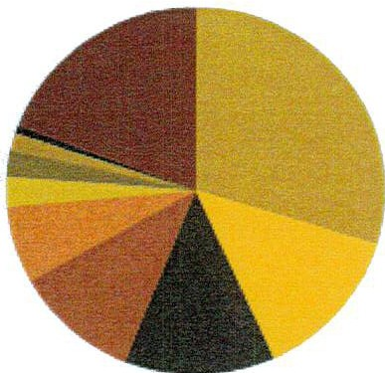
Job
function

Highest level of education

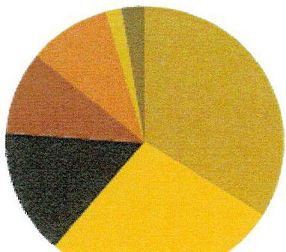
. l.l.,,;,-.. .,
- H q,1r,.,. O!dve / .,..,..
■A t.e;et:;W,;ti·
- Ot,v,r

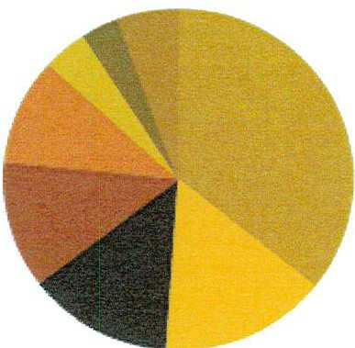
level of
senioirty

  - r' i:: 1,,'""r,,;J:Q..,..;J!,••,',,,•t:,C.-! .l')..1: Qt.J.i1f\C..> ·a1
  - 'Jt...'•oJr,, t1;:i:r., - !:1 !:.i• r
  - t •::i • .-.-r"l'l.li c. s]c.1

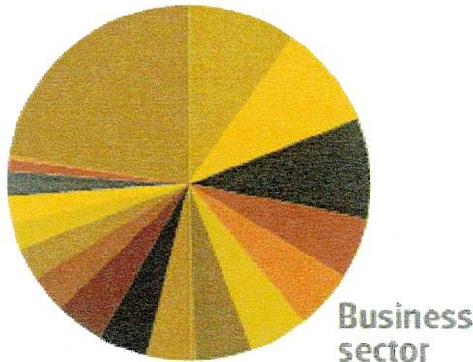
  - L.0:- r'\J - A.·•;lJ(,:..i ci r f .>c J"":,e, J[_t, ):'\t"r,f'94"",S::
  - i :Lai
. ,,,,.lrkctr ; /t..• c .a.l/"'1-. -·1 ...::;;'
  - i CL(..l;'JOr.
• ' a>ciSevr.,JJ..'"'!"l •1•:a.·
  - !.JIJ r-...,.f.J('it-, ·
  - ; (jf,Jr n·
  - n urt CJCon ·,tiJ; t •Ji;
  - t r-t:.ll
■il= i
■r•""'""'
  - Gow,.-nmr,n::i:ui,lc"""'""
■lle.sl!l-./Med c.l!
- nu.dtur;,al
■1 ,l !'\SD')>
■, ncr;::v
  - J<C".".c.:src t• & ll'ela n'
■Pr .:Jct X>t"

- C..O- !le l
-
- 141-
- (,":.rc r

- M.1 - ?ln;
- l tn.mcr:
•••

a t.Jf,.rr:r.-JOn
W t' rod-.:ctLlr•
- '-''-11:!>tlC

- MJ""1',,., D,,..1. nr,uu ■s.-,,,.,, M. ,..,,,
■M!l!d.e M""->j:.-. ■14:jrr <S'\i2t .L!.Of

- [iir ·tor
- J-JrJOr/ ... ;.(JI

- l' rd! e ...,ru
■()r.-,,,,
- "[ t-«-•

I•D·
in-cumbria's mission is simple
- to champion the best of (1I11brian business and business people in print and online. launched rn 2012. io-cumbria has now passed its 50lh edihon and has become Cumbria's must-read monthly business magazine.

A vibrant mix of features, profiles. in-depth analysis and views from a h quality roster of columnists, the magazine ams to inspire.

I •

From manage5 to chief execuoves and cha1nnen our website and newsletter have become essenual
sources of intelligence.

Covering eveiything from the latest deals, investments. appointtnents and developmen it not only provides the very latest infonnation, but also helps businesspeople to connect

With a strong reputation in lhe
marketpla,ce in-cumbna is the

educate and inform its loyal readership both inside and outside the county.
The website and the dall-/ in-rumbna AM Briefing bnng the very latest news to thousands of visito and subsaibers each dcFf
go-to source for business news and
viei.Ns. cejebratmg the wide variety of industJy sectors that make Cumbria's businesslandscape so rich

bria

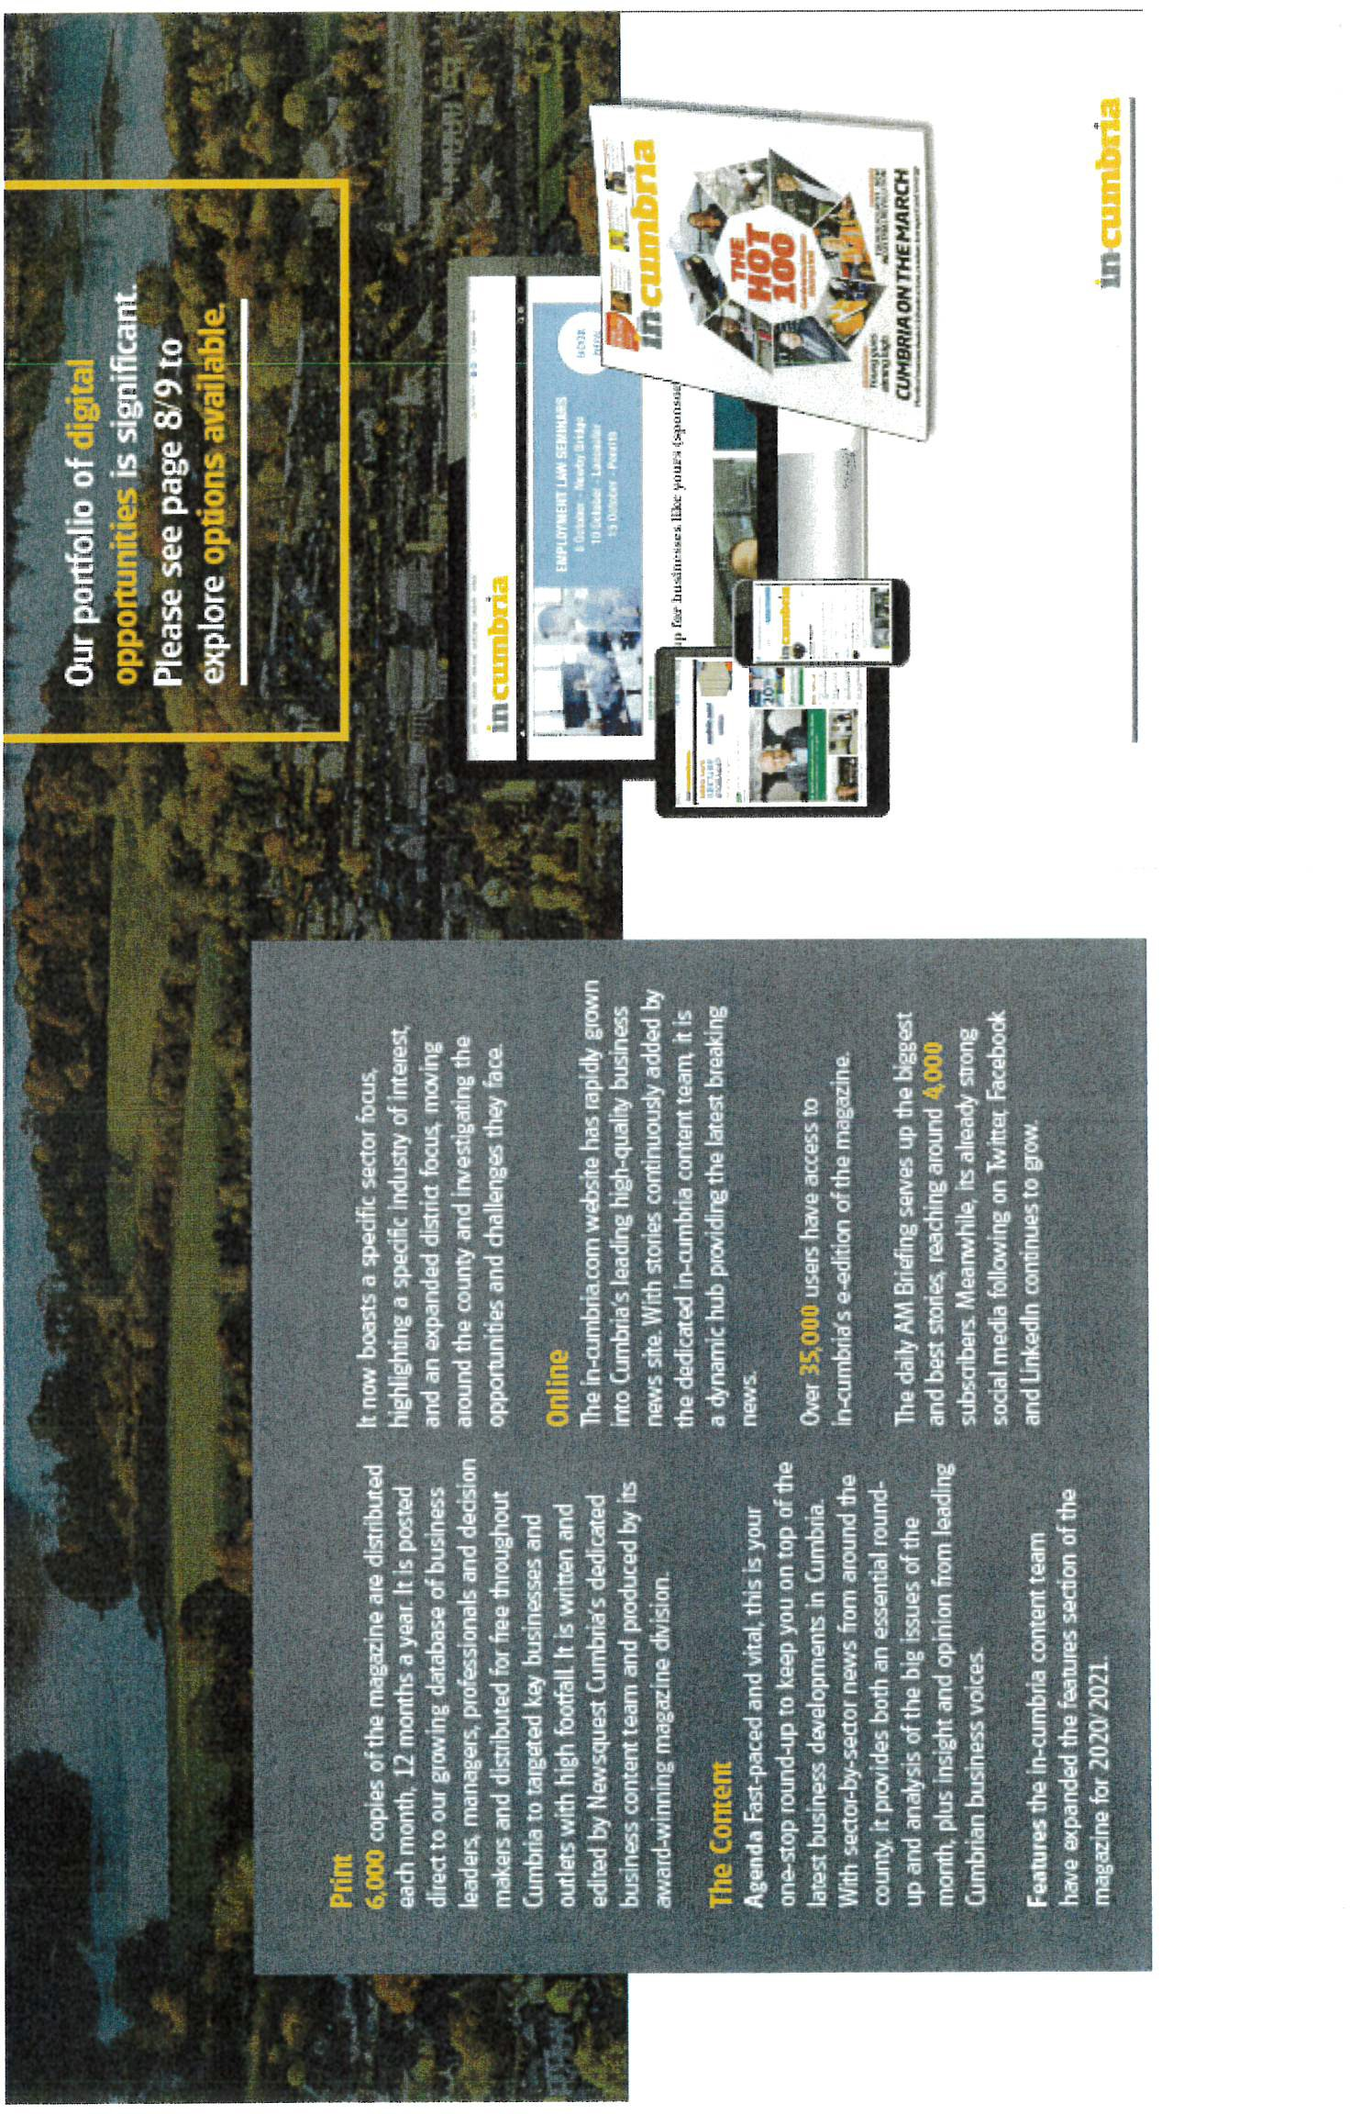

enceprofile
·
Reader demographic and subsaiber information

Readers of in-rumbna are ht ly 1nfl uent1al within the Cumbnan business market. with the ma1ority emplcve<I in management or sernor management positt0ns across key industry sectors.
8&/4
of our audience are influenrial senior management professionals

Highest level of education

- lk->:-e"
- tll dlur..-1:tor1!.:l:!ii0c"!?...l
- A !/!:l\'!.,lj
■Lt""

. ;. l ,71... :: J,c.-:"_;r ,,.'l".J l:.a.1l\f;1-:.i.r:c1r
  - • j, •:1 ..Jf'{ "'"''i:Jc.Jl lL<f"
  - K , -,r- .J: 'l 4· J 1.f J >c,, •:.

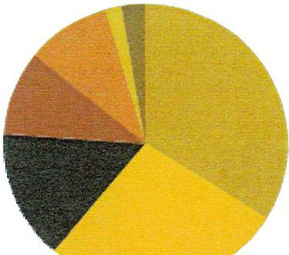
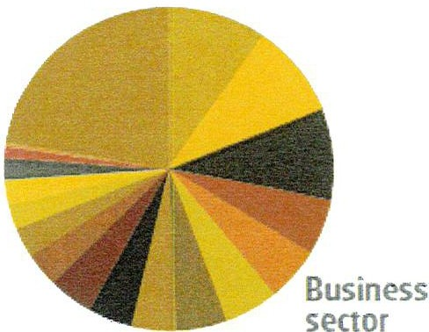
■( •,-:;, l'.,1" ..C '.:"i, a.,•. J
, ...,
.
- ; f''.,;.·).;.:?t.r .. /'i.,'"! .!"w ,.,,,•
- L'1'Jr k>.1
- '- :x,d , r .;,;. L.c,; 1 c.
■f\,", l ..,L,f ••·,- '"C'
■ (x.,r-.r

- i,t - - -·! -;: ,,,. ,,.. -"...

-;.•Yi. .I" ">':

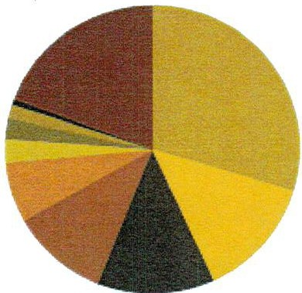
fob
function

Level of seniority
.■.t_.r..• T!
■►' ,:- j,
:
- ,i. ,.:, ,
ll.J:.:•• .:

  - IJl.'
..
c..••r r'.'le'r.: , t

- LH;K)r tr ,..._.r t:-rw-rlt ■M..tr\.c.tm1.."
- '.'w,,tM ■ f-in..m .:-e-
■I P-'. ■1•
- C<tt'r !

a Q;._. J! t"'S
a Prc-.d ct ,vr
- !,;'.!:'>' " '-

■M ::t •--ls:' !'ltrf"'I.. □ r t '1 -r ; ■ •11C.' '-1;U" .J f
■Ml'.1dt- i<.1an;tt,tM ■Adr- ;,.1'-'r .r ;."!r

- 0..• .:
- .ir-.J"'iu f t 'c.&.+,f'!" r

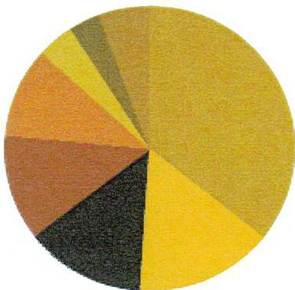
- ..:,.d.....- !.!•l nJ
- Dtr .r-1
- • ,U .J!., t'!l.·..::,i
■, "6,'. ,•_;,,.(J
- -,:,,­
- [ '\ ►,
- C".'..c;d.. \ i- e.G,.--ei·ow1M!"
■►·r 'f! J-1 •kJC
■c..· : t..-

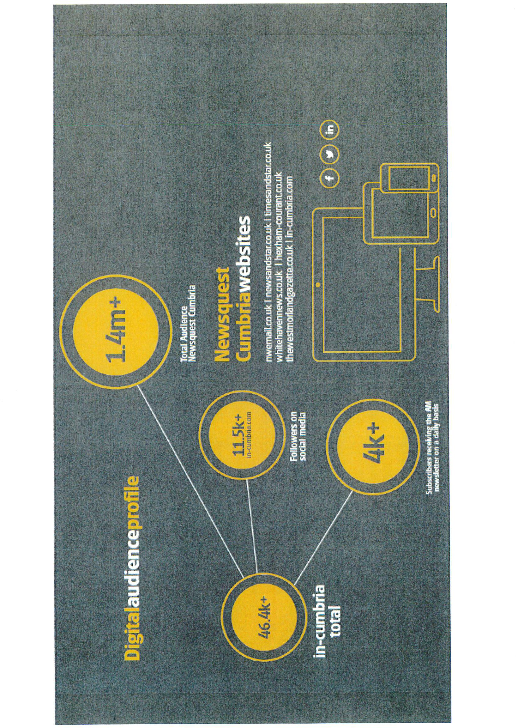

...ffl mwra-··-·
--·
.
-,,--I.

.1 ::: .c:-::,:-
,---;- - llffl•..
-1 .-
Opportunity

Option 1
-Multi-media mix that includes:

_ .-..,_.........a,..., I ·,

~-....-...·.....-...
-DOULBE PAGE SPREAD advert/advertorial style presence (com binat ion could be one full page advert & the other an advertorial style)
-Position ing, run of magazine (ROM) or can be placed to support a relevant feature covered that month
-10,000 digital impressions with multi-format positions
-Facebook (targeted activity utilising 24,000)

-NOS OF INSERTIONS & RATES (PER EDTIION}

ONE OFF 2-3 inserts 4-7 inserts 9-11inserts 12+ inserts

£668 (+vat) £588 (+vat) £522 (+vat) £455(+vat) £388 (+vat)

,n -cumbrlla

, .- -,., - .,,.

- ---

--., .-

Opportunity

, 1, p,•;1.1n,·
.. .... ..
· - - ;e - -
i ll·

.
•--
.
....,.

Option 2
-M ulti-media mix that includes:

1¾· -FULL Page advert/advertorial style presence
-Positioning, run of magazine (ROM} or can be placed to support a relevant feature
covered that month
-6,000 digital impressions with multi-format positions
-Facebook {targeted activity utilising 12,000)

NOS OF INSERTIONS & RATES {PER EDITION}

ONE OFF | 2-3 inserts | 4-7inserts | 9-H inserts | 12+ inserts
£426 (+vat) | £374 (+vat) | £331(+vat) | £289 (+vat) | £246 (+vat)

. -.- -\, -;--..--.
;J1---.' -
.
, _

Opportunity

Iii
Iii ... -· .

t .a 11s r-w.1v·,.,.1,1111.1,., .w'\k nou:.,.t.i,,,0:J,r
B ,
'.l. J.
J l,l 1 l f :S..,"'i1

Option 3
-Multi -media mix that includes:

-HALF Page advert/advertorial style presence (landscape or portrait shape}
-Positioning, run of magazine (ROM} or can be placed to support a relevant feature covered that month
-5,000 digital impressions with multi-format positions

NOS OF INSERTIONS & RATES (PER EDITION}

ONE OFF | 2-3_ir1 s_ert s | 4-7 inserts | 9-11 inserts | 12+ inserts
£219 (+vat) | £191(+vat) | £169 (+vat) | £147 (+vat) | £125 (+vat)

, e.l·.l. -• O- El-•-••-·o•.- ,
,::.::.,,_ I ;:-
•

Key Benefits
...1111.[ br\!u« 1b. oL1 m)ll1•ms
O O (i) O cc:::t

Our largest & most eye-catching digital ad format with creatives designed to deliver impact, drive response and grab the user's att ent ion .

The highest viewabil ity of any ad creative - the user doesn't need to scroll down to see the advert as i t s constantly in view

Com parab le to an outdoor/out of home billboard - high visibility, large creative size, key location. If a client has cut back on out of home advert ising (due to the current COVID19 impact on travel etc) then fixed skins are an excelle nt alternative.

Have your advert/message along-side our users as they browse relevant breaking new s - wit h a high engagement time

Take advantage of our Run of site offer and have your message displayed on 1 in 2 of our daily impressions across the entire site
C'U m
l i!!E::mu
On average Skins have the highest click th ru rate (CTR) of any digital display
creat ive we have
Ddi youknow?
Our , ,te u aff,c ,s up by
"" aver age of...
40%
When comp ar ed rn ou r
Pre-COVtD19 rraff,c
Skins are great for raising awareness of a particular message, for example, If a company is still open ing during the lockdown period, or is a company is now
offering delivery services.
Our packages include a m obile banner with the same creative, to ensure your message is displayed to our vast mobile audience

£675 (+vat) per month
LOCALiQ

I• u •a

Caroline Dean, Business Development Manager
Caroline.dean@localiq.co.uk
07753 811684

WTC 31/03/2022

Item 13

EDIBLE INSECTS SHOW

Purpose of the Report

To update Members on the arrangements for the Edible Insects Show and to authorise any expenditure.

  - INTRODUCTION

  - Following on from the success of previous shows held in 2019 and 2021 it was agreed that another Science Show be organised for 2022 and that it be staged in St Nicholas Gardens. The Edible Insects Show has been scheduled to take place on 23rd June 2022 and there will be two performances (am and pm).

The Science Show was approved by Members at a meeting of the Full Council held on 4th November 2021 (minute ref 1900/21
- refers).

  - The cost to stage the event is as follows:

    - Stefan Gates Fee
    - Travel & Sustenance
    - Overnight Accommodation -
    - Specialist equipment
    - Generator
£2,500 + VAT
£300 approx.
£100 + VAT
£1,300 + VAT approx. donated by Sunbelt Rentals

In addition to this a 15mtr x 9mtr marquee with flooring and 160 chairs are required. Quotes were sought from 4 suppliers and 2 quotes were received as follows:

    - Supplier A
    - Supplier B
£1880.80 + VAT
£1690.00 + VAT

  - Sponsorship has been secured for £3,500.00.

  - Any expenditure will be taken from the £20,000.00 Events Reserve Budget.

  - RECOMMENDATION

  - To note the information contained within the report and:

    - decide which Supplier should provide the marquee with flooring and 160 chairs;
    - to authorise that Fluid Productions, provide the specialist
staging equipment required at an approx. cost of
£1,300.00 + VAT
    - to agree the contract fee of £2,500.00 + VAT for the presenter of the Edible Insects Show;
    - to approve the approximate expenditure for travel and sustenance of £300 + VAT and overnight accommodation of £100.00 + VAT for the presenter of the Edible Insects Show;
    - to note that any expenditure will be offset by the secured sponsorship amount of £3,500.00

